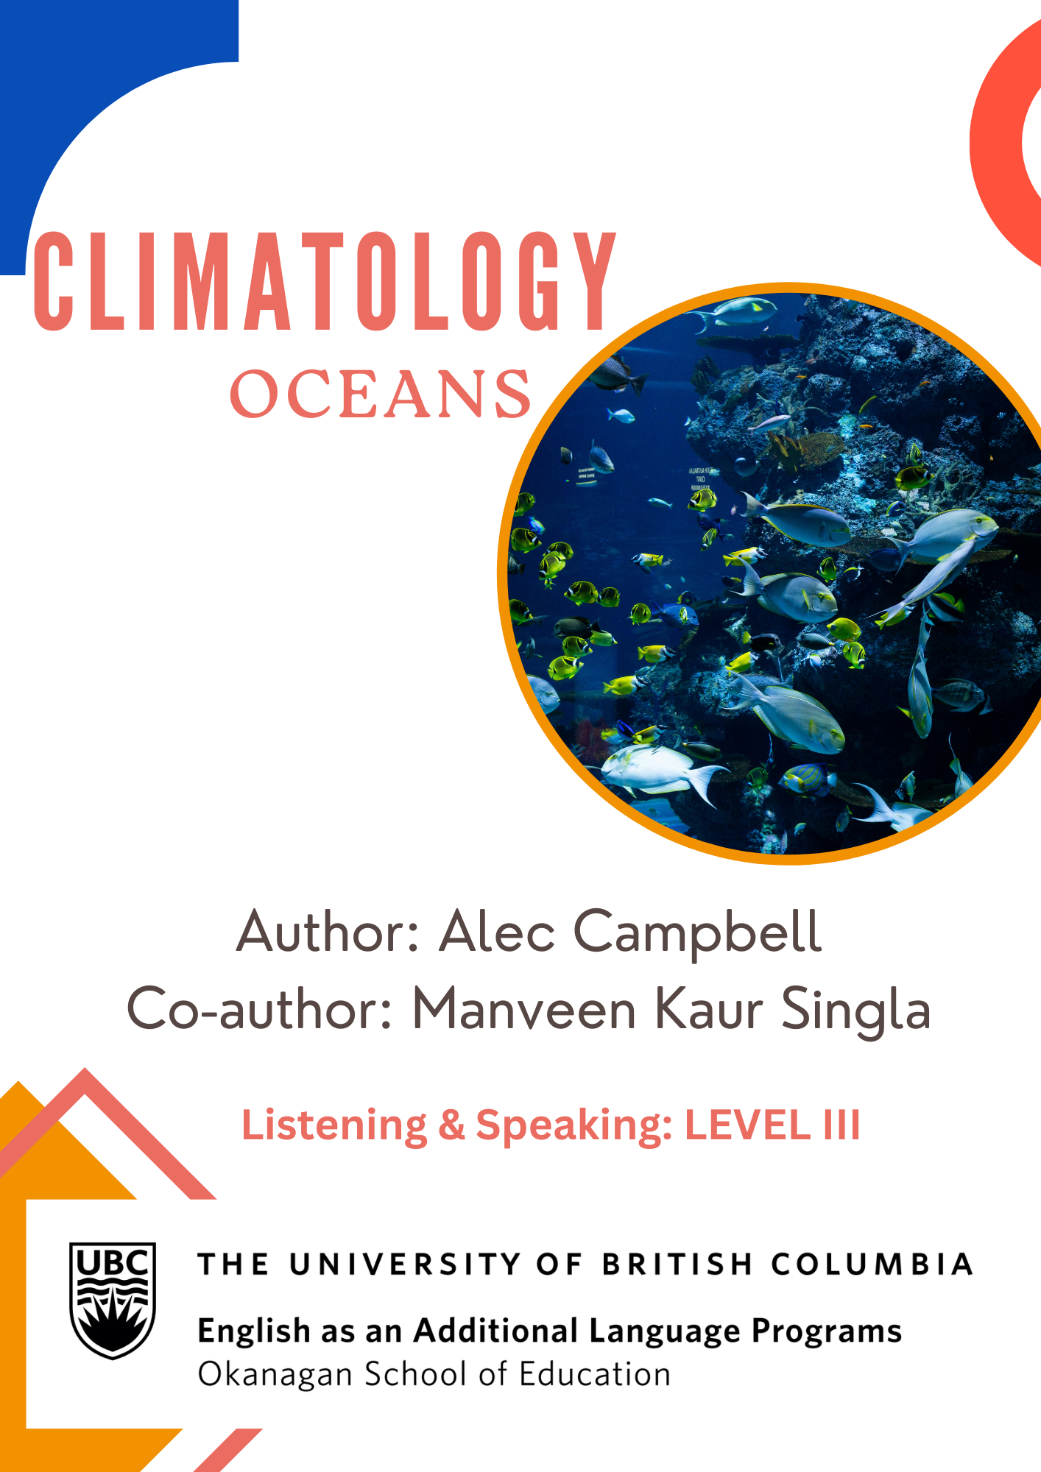

Climatology: Listening and Speaking Level III
Post Secondary Education Skills: Upper Intermediate English
(cc) Alec Campbell, Manveen Kaur Singla and the University of British Columbia’s Okanagan School of Education 2024
This work is licensed under a Creative Commons Attribution-Non-commercial-ShareAlike 4.0 International License.

Under the terms of the license, you are free to:
Share — copy and redistribute the material in any medium or format
Adapt — remix, transform, and build upon the material The licensor cannot revoke these freedoms as long as you follow the license terms.
Under the following terms:
Attribution — You must give appropriate credit, provide a link to the license, and indicate if changes were made. You may do so in any reasonable manner, but not in any way that suggests the licensor endorses you or your use.
NonCommercial — You may not use the material for commercial purposes.
ShareAlike — If you remix, transform, or build upon the material, you must distribute your contributions under the same license as the original.
Director, EAL Programs: Scott Roy Douglas
Program Coordinator, EAL Programs: Amber McLeod
Author: Alec Campbell
Co Author & Designer: Manveen Kaur Singla

This project was funded, in part, by the UBC Okanagan Open education Resources Grant Program.
Published by: English as an Additional Language Programs

Okanagan School of Education, University of British Columbia
1137 Alumni Avenue, Kelowna, British Columbia V1V 1V7
The photographs and artwork used in these materials may not be altered in any way without permission from the copyright holder, all information is listed on page 15.

Contents
Activity A: Class Discussion 4
Activity B: Partner Discussion 5
Activity C: Vocabulary 7
Activity D: Vocabulary Sentences 8
Activity E: Podcast Listening 10
Activity F: Comprehension Questions 11
Activity G: Extension Task 12
Activity H: Small Group Discussion………………………………………………..12
Activity I: Reflection Task 14
Photo and Video Credits 15

Activity A Class Discussion

Discuss these questions in small groups:

- Have you seen plastic pollution where you live?

- Have you visited the ocean?

- Why are oceans important?

- How can we protect oceans?

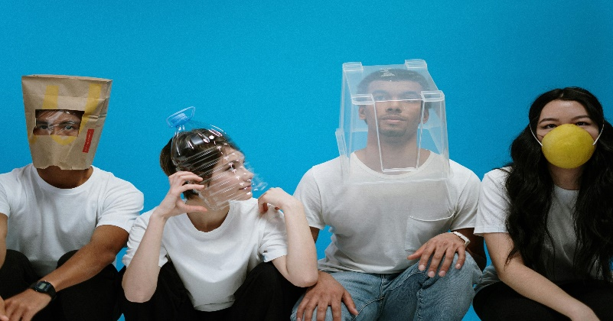
- How does ocean health affect us?
The average person eats 70,000 microplastics each year

99% of seabirds will be eating plastic by 2050

Activity B Partner Discussion

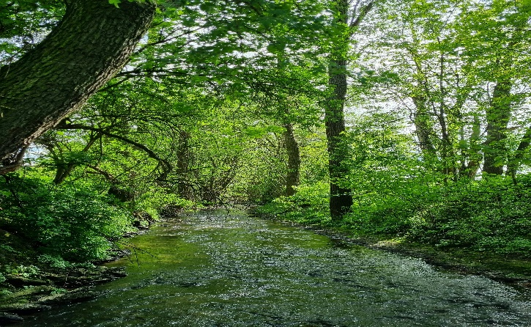

Discuss the following questions with a partner and write down your responses:

Questions:

- On a scale of 1 to 10, how clean is your home city?

- What does pollution look like in the rivers, lakes, and oceans of your home country?

- How does your culture approach pollution? Are they concerned about it?

- What kinds of laws and public initiatives exist in your home country to combat pollution?

- What kind of personal action do you take to reduce pollution? Examples?

Do You know?
A whopping 2 million plastic bags are used every minute worldwide.

Activity C Vocabulary

Here are some keywords from the Podcast. With a partner, write a short definition for each word. Then choose five words and create a picture/symbol to represent each one.
TERM | DEFINITION & PICTURE/SYMBOL
Decomposes
Environment
Current
Marine
Toxic
Biomagnification
Mercury
Recycling
Alternative
Dispose
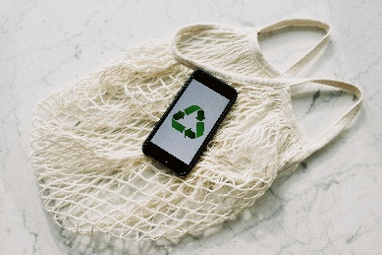

Activity D Vocabulary Sentences

Use the keywords mentioned below to fill in the blanks of the incomplete sentences. Each key word should only be used once.
Key Words:

Decomposes | Environment | Current
Marine | Toxic | Biomagnification
Mercury | Recycling | Alternative
Dispose | Founded

- An is the natural world or ecosystem surrounding and affecting an organism, including air, water, and land.
- _____________ is an adjective which refers to things that are in the sea or come from the sea.
- Poisonous things that cause harm to living organisms are considered

________________.

- There is a planet in the Solar System which is called ___________ , but this word is also the name of a silvery metal that is liquid at room temperature, and which pollutes the water.
- When we get rid of something by throwing it away, we ___________of those things.

- A choice or option that replaces or offers a substitute for something else is an ___________________.
- The noun form of __________is a continuous, directed movement of water in a sea or river.
- When a small fish eats something that is a toxin, the poison becomes more concentrated in the bigger fish which eats that smaller fish. This is called ___________________.
- When we convert waste into a reusable material, this is called _________.

- The verb “to find” appears as “found” in the past tense, but the verb “to found” is different and refers to when a person starts an organization. In the past tense, “to found” appears as “ ______________.”
- When a biological or chemical material naturally breaks into smaller pieces, it ____________________.
Did you know that every minute of every day a truckload of plastic is dumped into the ocean?

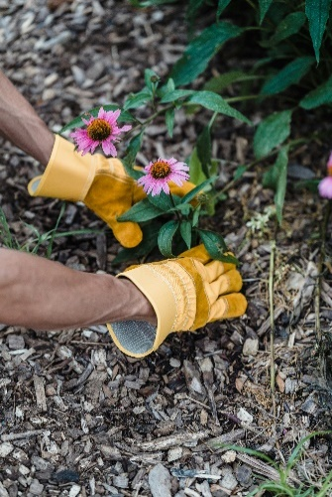

Activity E Podcast: Listening

Listen to the podcast about plastic pollution in the oceans two times and take notes:

Below is space for taking notes:

Did you know?
There could be more plastic than fish in the ocean by 2050

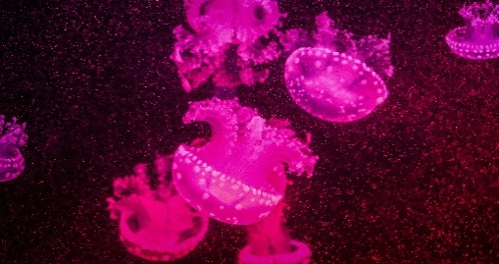

Did you know that one million plastic bottles are bought every minute?

Activity F Comprehension Questions

Answer the following comprehension questions with a partner or in small groups. Take notes so you can share your answers with the class:

Questions:

- How does the decomposition time of plastic compare to materials like paper and metal?

- According to the podcast, how does plastic pollution affect marine life and humans? Which biological processes are involved? Does this harm humans or fish more?

- What is the Great Pacific Garbage Patch, as mentioned in the podcast? How is it formed?

- What event inspired Boyan Slat to focus on solving the issue of plastic pollution?

- What is the phrase that comes from the “Three Rs?” Which one is most important to you? Why?

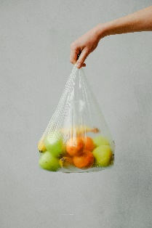

Activity G Extension Task

Watch the following video of Boyan Slat’s TEDx Talk from his younger years and think about how it affects you personally.
https://www.youtube.com/watch?v=ROW9F-c0kIQ

Activity H Small Group Discussion

Join a group of 4-5 students and answer the following questions together:

Questions:

- How did the information in the TEDx Talk by Boyan Slat differ from what was discussed in the podcast? Were there any contrasting points or new insights?

- After listening to the TEDx Talk and the podcast, which aspects of the plastic pollution issue feel most relevant or urgent to you personally? Why?

- How do the solutions proposed by Boyan Slat in his TEDx Talk have the potential to impact global efforts against plastic pollution? Are there any limitations?

- Boyan Slat started The Ocean Cleanup at a very young age. How does his story inspire you when thinking about your own potential to contribute to environmental solutions?

- With your group, come up with an innovative method people could adopt to better avoid polluting the planet with plastic and write it down. Be prepared to share it.

Activity I Reflection Task

Listen to the music video entitled ‘Beyond the Sea’ and think of reasons why we might want to preserve the world’s oceans.
https://www.youtube.com/watch?v=ta3jHcbslQw

Photo and Audio Credits

Cover Photo: Photo by Hung Tran: https://www.pexels.com/photo/school-of-fish-in-water-3699434/
Page 4. Photo by Naja Bertolt Jensen on Unsplash
Photo by cottonbro studio: https://www.pexels.com/photo/people-wearing-diy-masks-3951628/
Page 5. Photo by Edka K: https://www.pexels.com/photo/a-creek-runs-through-a-forested-area-with- trees-20308702/
Photo by Igor Omilaev on Unsplash
Page 6. Photo by Marc Newberry on Unsplash
Page 7. Photo by Nataliya Vaitkevich: https://www.pexels.com/photo/fish-in-a-clear-plastic-on-seashore-4813970/
Page 8. Photo by ready made: https://www.pexels.com/photo/mobile-phone-with-green-recycling-sign-and-mesh-bag-3850512/

Page 9. Photo by Like a Lot: https://www.pexels.com/photo/a-truck-loaded-with-plastic-trash-driving-on-a-street-in-city-17044490/

Page 10. Photo by Lara Jameson: https://www.pexels.com/photo/person-in-yellow-rain-boots-holding-yellow-and-purple-flower-9324348/

Photo by Magda Ehlers: https://www.pexels.com/photo/pink-jellyfish-2832769/

Page 11. Photo by Lara Jameson: https://www.pexels.com/photo/nature-man-blue-rubber-9324328/

Page 12. Photo by Anna Shvets: https://www.pexels.com/photo/fruits-in-a-plastic-bag-3645504/

Photo by fauxels: https://www.pexels.com/photo/photo-of-people-having-meeting-3183186/

Page 15. Photo by Bich Tran: https://www.pexels.com/photo/white-paper-with-note-669986/
Podcast recorded by LLED Practice Teacher Alec Campbell
Background Tracks of Seagulls and Ocean Waves: https://freesound.com/
TEDx Talk by Boyan Slat: https://www.youtube.com/watch?v=ROW9F-c0kIQ
Bobby Darin – Beyond the Sea https://www.youtube.com/watch?v=ta3jHcbslQw
Informational Data from https://givingcompass.org/article/10-facts-about-plastic-pollution-you-absolutely-need-to-know

