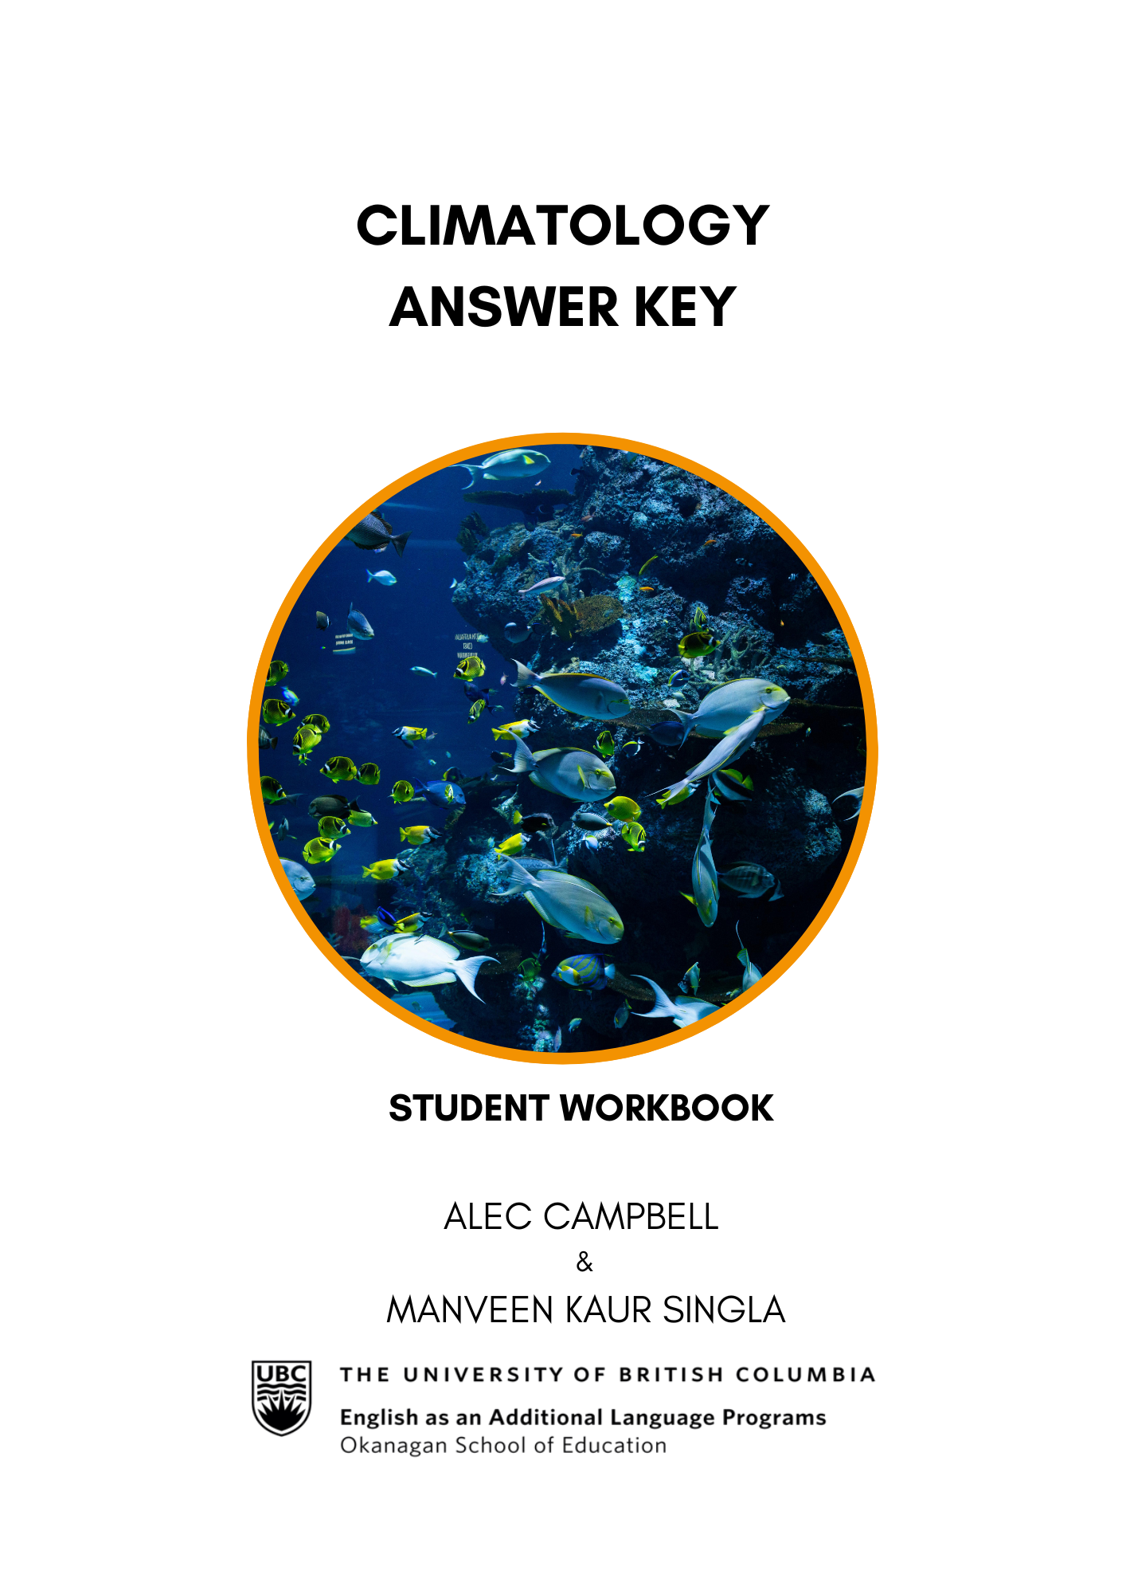

Climatology: Listening and Speaking Level III
Post Secondary Education Skills: Upper Intermediate English
(cc) Alec Campbell, Manveen Kaur Singla and the University of British Columbia’s Okanagan School of Education 2024
This work is licensed under a Creative Commons Attribution-Non-commercial-ShareAlike 4.0 International License.

Under the terms of the license, you are free to:
Share — copy and redistribute the material in any medium or format
Adapt — remix, transform, and build upon the material The licensor cannot revoke these freedoms as long as you follow the license terms.
Under the following terms:
Attribution — You must give appropriate credit, provide a link to the license, and indicate if changes were made. You may do so in any reasonable manner, but not in any way that suggests the licensor endorses you or your use.
NonCommercial — You may not use the material for commercial purposes.
ShareAlike — If you remix, transform, or build upon the material, you must distribute your contributions under the same license as the original.
Director, EAL Programs: Scott Roy Douglas
Program Coordinator, EAL Programs: Amber McLeod
Author: Alec Campbell
Co Author & Designer: Manveen Kaur Singla

This project was funded, in part, by the UBC Okanagan Open education Resources Grant Program.
Published by: English as an Additional Language Programs

Okanagan School of Education, University of British Columbia
1137 Alumni Avenue, Kelowna, British Columbia V1V 1V7
The photographs and artwork used in these materials may not be altered in any way without permission from the copyright holder, all information is listed on page 15.

Contents
Activity A: Class Discussion 4
Activity B: Partner Discussion 4
Activity C: Vocabulary 5
Activity D: Vocabulary Sentences 6
Activity E: Podcast Listening 7
Activity F: Comprehension Questions 7
Activity G: Extension Task 9
Activity H: Small Group Discussion 9
Activity I: Reflection Task 10

Activity A: Class Discussion
(Page 4 in student workbook)
Discuss these questions in small groups:

- Have you seen plastic pollution where you live?
Answers will vary.
- Have you visited the ocean?
Answers will vary.
- Why are oceans important?
Answers will vary.
- How can we protect oceans?
Answers will vary.
- How does ocean health affect us?
Answers will vary.

Activity B: Partner Discussion
(Page 5-6 in student workbook)
Discuss the following questions with a partner and write down your responses:

- On a scale of 1 to 10, how clean is your home city?
Answers will vary.
- What does pollution look like in the rivers, lakes, and oceans of your home country?
Answers will vary.
- How does your culture approach pollution? Are they concerned about it?
Answers will vary.
- What kinds of laws and public initiatives exist in your home country to combat pollution?
Answers will vary.
- What kind of personal action do you take to reduce pollution? Examples?
Answers will vary.

Activity C: Vocabulary
(Page 7 in student workbook)
Here are some keywords from the Podcast. With a partner, write a short definition for each word. Then choose five words and create a picture/symbol to represent each one.
TERM | DEFINITION & PICTURE/SYMBOL
Decomposes  (Verb) | to break down something into smaller and simpler parts;
Environment  (n) | the natural world in which people, animals and plants live
Current  (n) | A current is a steady and continuous flowing movement of some of the water in a river, lake, or sea.
Marine  (adj) | Marine is used to describe things relating to the sea or to the animals and plants that live in the sea.
Toxic  (adj) | A toxic substance is poisonous.
Biomagnification  (n) | the increasing concentration of toxic substances within each successive link in the food chain
Mercury  (n) | Mercury is a silver-coloured liquid metal that is used especially in thermometers and barometers.
Recycling  (n) | the act of processing used materials into new products for further use
Alternative  (n) | a thing that you can choose to do or have out of two or more possibilities
Dispose  (verb) | to throw out or away

Activity D: Vocabulary Sentences
(Page 8-9 in student workbook)
Use the keywords mentioned below to fill in the blanks of the incomplete sentences. Each key word should only be used once.

Key Words:

Decomposes | Environment | Current
Marine | Toxic | Biomagnification
Mercury | Recycling | Alternative
Dispose | Founded

- An environment is the natural world or ecosystem surrounding and affecting an organism, including air, water, and land.
- Marine is an adjective which refers to things that are in the sea or come from the sea.
- Poisonous things that cause harm to living organisms are considered toxic.

- There is a planet in the Solar System which is called mercury, but this word is also the name of a silvery metal that is liquid at room temperature, and which pollutes the water.
- When we get rid of something by throwing it away, we dispose of those things.

- A choice or option that replaces or offers a substitute for something else is an alternative.
- The noun form of current is a continuous, directed movement of water in a sea or river.
- When a small fish eats something that is a toxin, the poison becomes more concentrated in the bigger fish which eats that smaller fish. This is called biomagnification.
- When we convert waste into a reusable material, this is called recycling.

- The verb “to find” appears as “found” in the past tense, but the verb “to found” is different and refers to when a person starts an organization. In the past tense, “to found” appears as “founded.”

- When a biological or chemical material naturally breaks into smaller pieces, it decomposes.

Activity E: Podcast Listening
(Page 10 in student workbook)
Listen to the podcast about plastic pollution in the oceans two times and take notes.
Answers will vary.

Activity F: Comprehension Questions
(Page 11 in student workbook)
Answer the following comprehension questions with a partner or in small groups. Take notes so you can share your answers with the class:

- How does the decomposition time of plastic compare to materials like paper and metal?
Plastic is a material, and it takes a very long time to decompose, longer
than paper and longer than metal.

- According to the podcast, how does plastic pollution affect marine life and humans? Which biological processes are involved? Does this harm humans or fish more?
Marine animals, such as whales, seabirds, and turtles, have been discovered dead from the high number of plastic particles that they consume when they are trying to eat. The plastic harms humans too because the toxic chemicals that fish eat become more concentrated in the animals which eat the fish, including humans, in a process called biomagnification. According to the podcast it harms humans more.

- What is the Great Pacific Garbage Patch, as mentioned in the podcast? How is it formed?
Pieces of plastic in earth’s oceans are reduced to smaller pieces by waves and ocean currents which then form groups with a high density of plastic, such as the Great Pacific Garbage Patch.

- What event inspired Boyan Slat to focus on solving the issue of plastic pollution?
Plastic is a material, and it takes a very long time to decompose, longer
than paper and longer than metal.

- What is the phrase that comes from the “Three Rs?” Which one is most important to you? Why?
Answers will vary.

Activity G: Extension Task
(Page 12 in student workbook)
Watch the following video of Boyan Slat’s TEDx Talk from his younger years and think about how it affects you personally.
https://www.youtube.com/watch?v=ROW9F-c0kIQ

Activity H: Small Group Discussion
(Page 12-13 in student workbook)
Join a group of 4-5 students and answer the following questions together:

- How did the information in the TEDx Talk by Boyan Slat differ from what was discussed in the podcast? Were there any contrasting points or new insights?
Answers will vary.

- After listening to the TEDx Talk and the podcast, which aspects of the plastic pollution issue feel most relevant or urgent to you personally? Why?
Answers will vary.

- How do the solutions proposed by Boyan Slat in his TEDx Talk have the potential to impact global efforts against plastic pollution? Are there any limitations?
Answers will vary.

- Boyan Slat started The Ocean Cleanup at a very young age. How does his story inspire you when thinking about your own potential to contribute to environmental solutions?
Answers will vary.

- With your group, come up with an innovative method people could adopt to better avoid polluting the planet with plastic and write it down. Be prepared to share it.
Answers will vary.

Activity I: Reflection Task
(Page 14 in student workbook)

Listen to the music video entitled ‘Beyond the Sea’ and think of reasons why we might want to preserve the world’s oceans.
https://www.youtube.com/watch?v=ta3jHcbslQw
Answers will vary.

