Laurel Packing House: Listening and Speaking Level III
Post Secondary Education Skills: Upper Intermediate English
(cc) Dora Chen, Ashley Johnston and the University of British Columbia’s Okanagan School of Education 2024
This work is licensed under a Creative Commons Attribution-Non-commercial-ShareAlike 4.0 International License.

Under the terms of the license, you are free to:
Share — copy and redistribute the material in any medium or format
Adapt — remix, transform, and build upon the material The licensor cannot revoke these freedoms as long as you follow the license terms.
Under the following terms:
Attribution — You must give appropriate credit, provide a link to the license, and indicate if changes were made. You may do so in any reasonable manner, but not in any way that suggests the licensor endorses you or your use.
NonCommercial — You may not use the material for commercial purposes.
ShareAlike — If you remix, transform, or build upon the material, you must distribute your contributions under the same license as the original.
Director, EAL Programs: Scott Roy Douglas
Program Coordinator, EAL Programs: Amber McLeod
Author: Dora Chen
Co Author & Design: Ashley Johnston

This project was funded, in part, by the UBC Okanagan Open education Resources Grant Program.
Published by: English as an Additional Language Programs

Okanagan School of Education, University of British Columbia
1137 Alumni Avenue, Kelowna, British Columbia V1V 1V7
The photographs and artwork used in these materials may not be altered in any way without permission from the copyright holder, all information is listed on page 15.

Contents
Section 1. INTRODUCING THE LAUREL PACKING HOUSE 3
Activity A Discussion Questions 3
Activity B Vocabulary 4
Activity C Research & Discussion: 6
Activity D Pictionary Activity 7
Activity E Optional Vocabulary Activity 8
SECTION 2. LAUREL PACKING HOUSE VIDEO 9
Activity F Taking Notes 9
Activity G Comprehension Questions 10
SECTION 3. REFLECTION & CRITICAL THINKING 12
Activity H Reflection Questions 12
Activity I Research Questions 12
Photo Credits 15

​
​
​
​

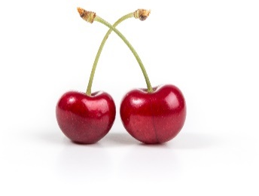
Section 1. INTRODUCING THE LAUREL PACKING HOUSE

Activity A Discussion Questions

In small groups of 2-4, discuss the questions below. Your instructor may choose to assign specific questions to each group.

- Have you ever been on a farm tour, wine tour, or visited an orchard? What was your favorite part?

- Did you know that Kelowna is commonly known as the “orchard city” of Canada? What do you think this means & why might it be called this?

- Do you think apple trees and cherry trees naturally grow in the Okanagan Valley?

- What is your favorite fruit? Where does it grow? Can you find them at the grocery stores here in British Columbia?

- What fruits grow in the region that you grew up in? (Naturally or agriculturally)

- Do you have any questions about orchards? What is something you want to know about orcharding in Kelowna?
Did you know that Pears are one of the few fruits that don’t ripen on the tree?
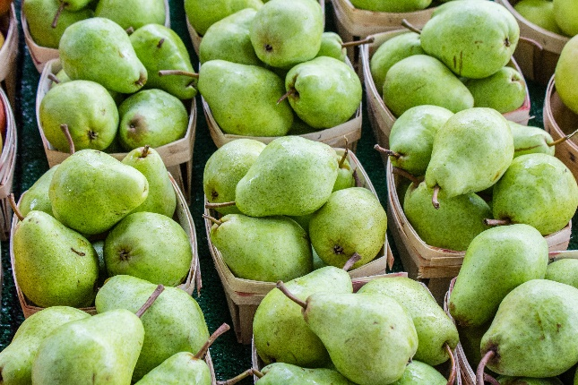

Activity B Vocabulary

Before you watch the video, review the keywords below. With a partner, write a short definition for each word. Then choose six words to write a sentence with.
TERM | DEFINITION & EXAMPLE SENTENCE
Unceded
Settler
Reside
Intentional
Treaty
Syilx
Indigenous
Colloquial
Subdivide
Discard
Reconciliation
Flume
Fertile
Irrigation
Littering
Citrusy
Industrial
Pesticide
Organic
Budding | Did you know that there are over 2,000 different varieties of peaches?
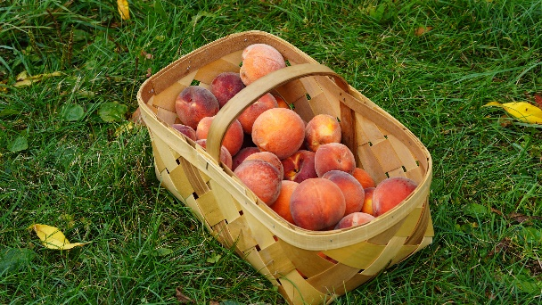

Activity C Research & Discussion:

The video for this unit is based on the Laurel Packing House. The Laurel Packinghouse is a heritage building that houses the Okanagan Wine and Orchard Museum. Before watching the video, visit their website and share your answers with a classmate or in small groups. https://www.kelownamuseums.ca/museum/laurel-packinghouse/
- Where is the Laurel packing house located?

- When was the Laurel packing house built?

- What is the main purpose of the Laurel packing house today?

- What can you find in the Laurel Packing House?

- What are some upcoming social events at the Laurel Packing House?

- What is the Laurel Square and when did it open?

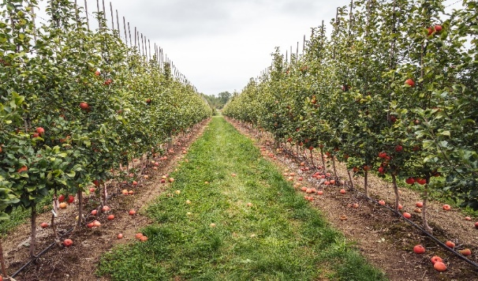
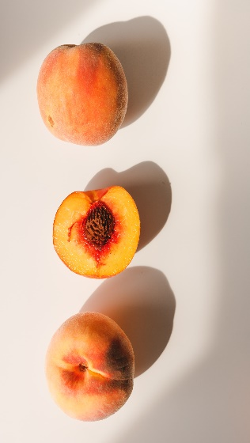
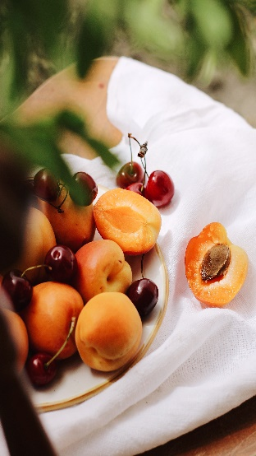
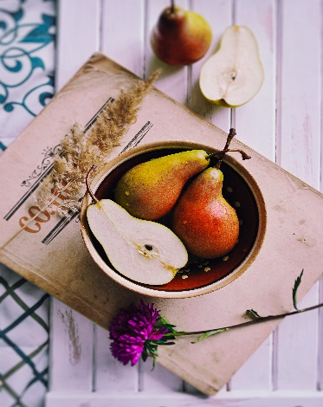
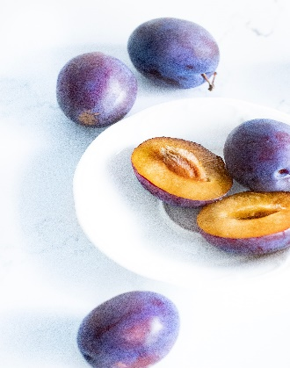

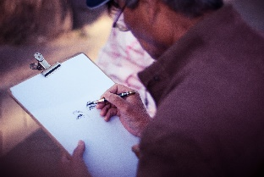
Activity D Pictionary Activity

Divide the class into two groups for a game of Pictionary.

Your instructor will assign how many words each group will draw
(i.e. 5 -10 words). One person must sketch “the prompt”, i.e. the vocabulary word. The person sketching has 1 minute to draw the word without using letters or numbers. If their team guesses the word, a new player will run up to the front to pick a new word and start drawing.

Talking and hand gestures are not allowed by the drawer. The group that gets the most words right is the winner.
Below are the words for the drawers. These words will be cut up, folded, and put into a bowl. Drawers will not see what word they are picking until the timer begins.

Orchard | Discard | Industrial
Apple Picking | Citrusy | Irrigate
Pesticides | Budding | Subdivide
Treaty | Pesticides | Flume

Activity E Optional Vocabulary Activity
\
Look at the example below. Choose a website from the list, to create your own word search.
Below is a list of some suggested websites to use:
https://www.edu-games.org/word-games/wordsearch/word-search-clues-maker.php
https://puzzlemaker.discoveryeducation.com/word-search
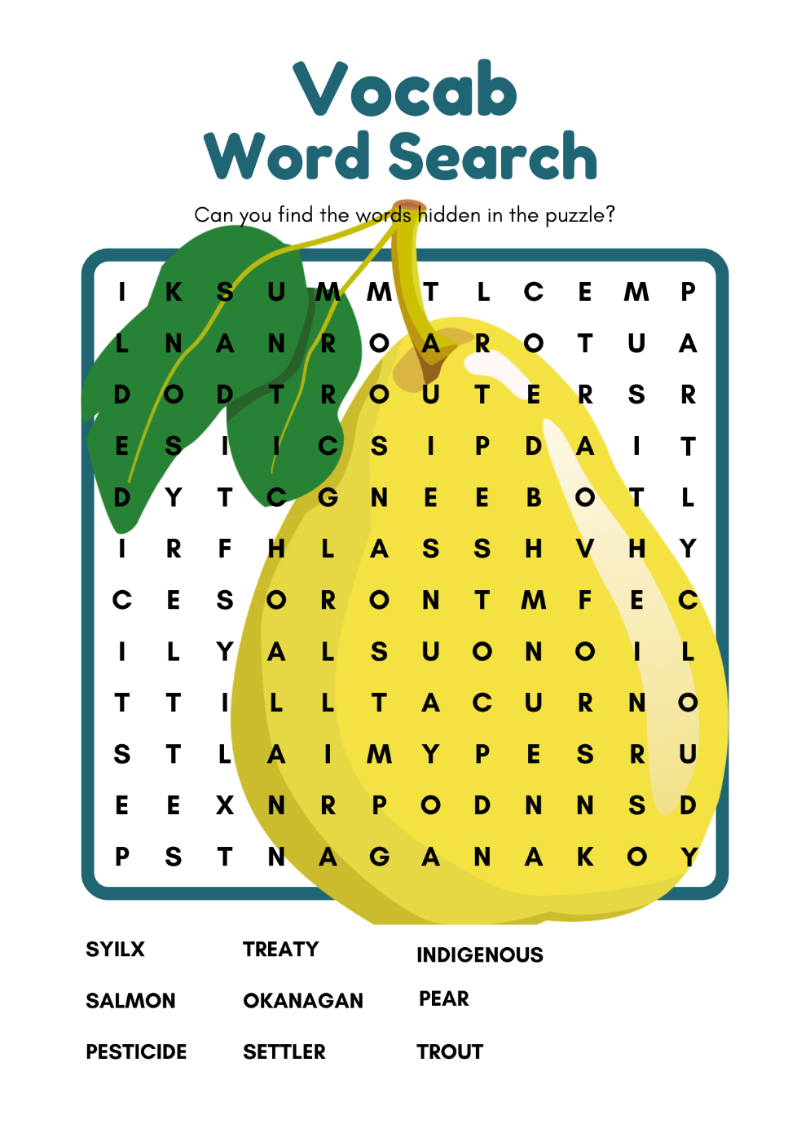
https://www.canva.com/create/word-search/
Sample is too easy!

Add more vocabulary words!
Double check spelling!

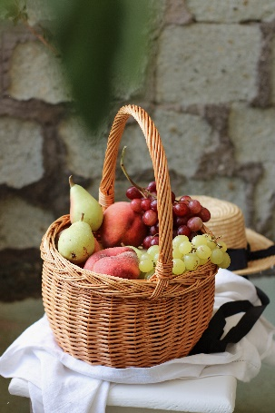
SECTION 2. LAUREL PACKING HOUSE VIDEO

Activity F Taking Notes

While watching the video, take detailed notes.
Tips for note taking.
- Write in short form, abbreviations, bullets and/or phrases.
- Don’t worry about spelling or proper sentence structure.
- Use headings.
- Write in your own words.
- Highlight, circle or draw an or * for important information.
- Compare your notes with classmates to see what each of you thought was important.
Below is space for taking notes:
After the apple trees are planted, they take 4-5 years to produce their first fruits.

Activity G Comprehension Questions

Read and answer the following questions.
Share your answers with a classmate or in small groups.
- What fruit did the Indigenous, Syilx, people intentionally plant and harvest?
  - Apples, peaches, and apricots
  - Saskatoon berries and sumac berries
  - Cherries, plums, and pears

- What is one challenge that Okanagan orchard farmers face in terms of pests?
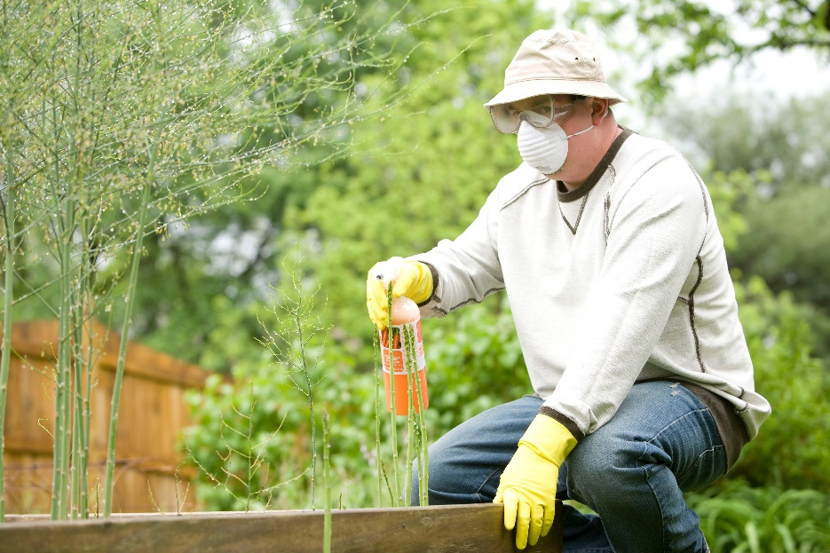
  - Apple maggot
  - Codling moth
  - Both a and b

- What are some methods used to address pest challenges in orchards?
  - Pesticides and fungicides
  - Plastic owls and scarecrows
  - Both a and b

- Who was the first group of people who started small scaled orchards in the Okanagan? And what kind of fruit were they growing?
  - The European settler and apples
  - The Syilx people and Saskatoon berries
  - The Syilx people and Sumac berries

- What are water flumes?
  - a wooden or metal channel that is used to transport water
  - a watering system used for irrigation
  - Both a and b
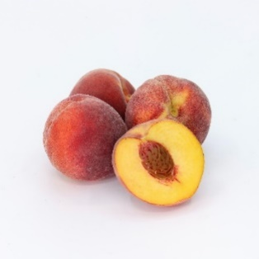
- What is another name for Kelowna?
  - The Garden city
  - The Orchard heaven
  - The Orchard City
  - Both a & c

- What are some negative consequences from straightening mission creek?
  - Salmon had no where to rest or spawn
  - Indigenous people of Okanagan (Syilx) had less salmon in their diets
  - Increase in water temperature & climate change
  - All of the above

- How did the Syilx people use Saskatoon berries (Siya)?
  - Trained the stems and branches to grow straight for arrow making
  - They would make baskets out of them
  - They would dry them and eat them over the winter
  - Both a and c
  - All of the above

- Why was the mission creek straightened?
  - Because it was good for the salmon & trout
  - it made it easier to build houses
  - it made it easier to build golf courses
  - both b & c

SECTION 3. REFLECTION & CRITICAL THINKING

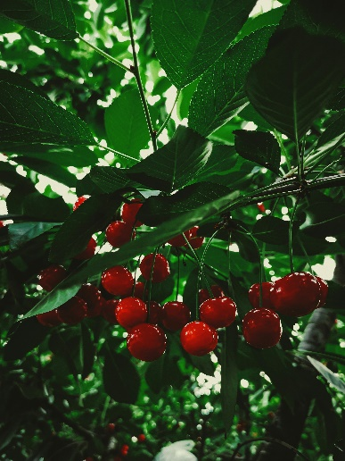
Activity H Reflection Questions

After viewing the video, get into small groups of 2-3 and discuss the questions below.
What are the economic benefits of orchards to a region? Consider how they might contribute to a local economy.

- What do you think is the most important orchard crop in Okanagan Valley and why?

- In what ways do orchards impact the ecosystem and local biodiversity?

- What role do you think orchards play in preserving agricultural heritage and connecting people to nature?

- How do you think the weather and the climate in Kelowna affect the growth of fruits and vegetables in orchards?

Activity I Research Activity

Select one of the three options provided below and conduct research to answer the questions.
OPTION #1: With a classmate, choose one of the following orchards from the Okanagan Valley:
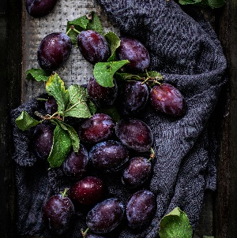
- Twin Oaks Organic Orchard
- Arndt Orchards
- Bella Rosa Orchards
Research the following:
- What products and services do they sell?
- Where are their products shipped from and to?
- When was it established?
- What makes this orchard unique/popular?
- Do they list prices online? If so, how much?
- Where can you purchase their product(s)?

OPTION #2: Write your own Land acknowledgment (you heard a land acknowledgment at the beginning of the video) and think about the following questions:

  - List of questions:
- Define your identity: Where do you come from? What languages do you speak? Are you a sister, father, son, aunt, student, teacher, volunteer, etc.?
- Who were the first settlers/peoples where you come from?
- What do you appreciate about the land where you grew up?
- Where are you now? Who are the Indigenous people’s lands that you reside on today?
- What are you grateful for about the land that you currently reside on?
- Do you feel you have a relationship with the land where you are or where you come from? What can you do to learn more about the ecosystem and land that you are on?
- What is one thing you can commit to as a way of learning about the Indigenous people here or helping care for this land?

  - Share your land acknowledgment with a classmate or small group.

OPTION #3: Research a kind of fruit from your home country and find out some interesting facts about it such as:
- What region & climate does it grow in?
- When is it planted and is harvested?
- How is it packed & shipped? (Where does this happen?)
- Do farmers require any special tools for planting, watering, or harvesting?
- What types of sprays are used to help keep it safe from pests & diseases? Are any of these sprays organic?
- Do places in your home country advertise their product for tourism or events like the orchard industry in Canada? Why do you think they might or might not?

Photo Credits

Page 3. Cherries: https://unsplash.com/photos/lZ8onQ1wuY8
Page 3. Pears packed: https://unsplash.com/photos/RW6Wz9QaoKk
Page 5. https://unsplash.com/photos/RtV7VDIN6j4
Page 6. Apple Orchard: https://unsplash.com/photos/Mcwg75fwYkM
Page 6. Apricot & cherries: https://unsplash.com/photos/-uc0i9306RE
Page 6. Pears: https://unsplash.com/photos/GxSg5E7RKhE
Page 6. Plums : https://unsplash.com/photos/cNPRpLn-vA8
Page 6 Peaches: https://unsplash.com/photos/dAjYxJrcdd86
Page 7. https://unsplash.com/photos/jD5RVR9BAS8
Page 9. https://unsplash.com/photos/zLCR7RsxYGs
Page 9. https://unsplash.com/photos/23XEGHMH5dQ
Page 10. https://unsplash.com/photos/wz3ijPHvL54
Page 11. https://unsplash.com/photos/HtUBBdNDxpQ
Page 11. https://unsplash.com/photos/bNuil3PcTSM
Page 12: Cherries : https://unsplash.com/photos/red-round-fruits-on-green-leaves-bbxwU3HtRkM

Page 12: Plums : https://unsplash.com/photos/violet-grapes-dz3TGztQIPE

​
​​

