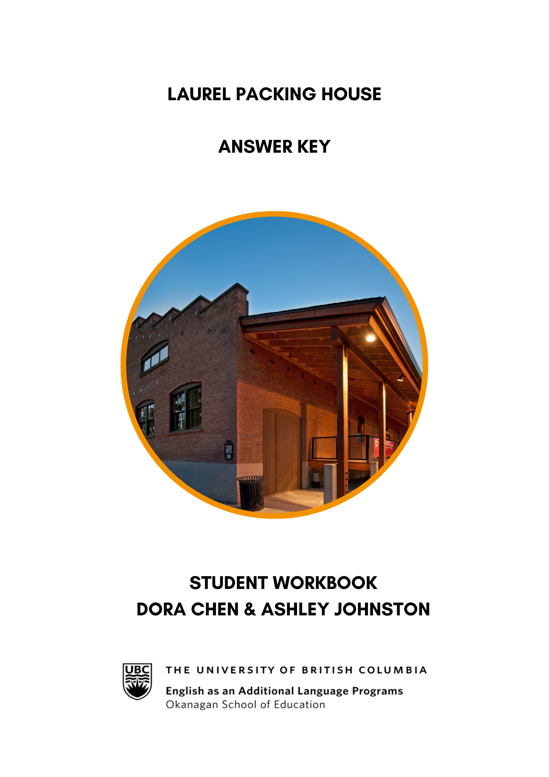
Laurel Packing House: Listening and Speaking Level III
Post Secondary Education Skills: Upper Intermediate English
(cc) Dora Chen, Ashley Johnston and the University of British Columbia’s Okanagan School of Education 2024
This work is licensed under a Creative Commons Attribution-Non-commercial-ShareAlike 4.0 International License.

Under the terms of the license, you are free to:
Share — copy and redistribute the material in any medium or format
Adapt — remix, transform, and build upon the material The licensor cannot revoke these freedoms as long as you follow the license terms.
Under the following terms:
Attribution — You must give appropriate credit, provide a link to the license, and indicate if changes were made. You may do so in any reasonable manner, but not in any way that suggests the licensor endorses you or your use.
NonCommercial — You may not use the material for commercial purposes.
ShareAlike — If you remix, transform, or build upon the material, you must distribute your contributions under the same license as the original.
Director, EAL Programs: Scott Roy Douglas
Program Coordinator, EAL Programs: Amber McLeod
Author: Dora Chen
Co Author & Design: Ashley Johnston

This project was funded, in part, by the UBC Okanagan Open education Resources Grant Program.
Published by: English as an Additional Language Programs

Okanagan School of Education, University of British Columbia
1137 Alumni Avenue, Kelowna, British Columbia V1V 1V7
The photographs and artwork used in these materials may not be altered in any way without permission from the copyright holder, all information is listed on page 15.

Contents
Activity A: Discussion Questions 4
Activity B: Vocabulary 4
Activity C: Research and Discussion 6
Activity D: Pictionary Activity 7
Activity E: Optional Vocabulary Activity 8
Activity F: Taking Notes 9
Activity G: Comprehension Questions 9
Activity H: Reflection Questions 10
Activity I: Research Activity 11

Activity A: Discussion Questions
(Page 3 in student workbook)
Introducing the Laurel Packing House:
In small groups of 2-4, discuss the questions below. Your instructor may choose to assign specific questions to each group.

- Have you ever been on a farm tour, wine tour, or visited an orchard? What was your favorite part?
Answers will vary.
- Did you know that Kelowna is commonly known as the “orchard city” of Canada? What do you think this means & why might it be called this?
Answers will vary.
- Do you think apple trees and cherry trees naturally grow in the Okanagan Valley?
Answers will vary.
- What is your favorite fruit? Where does it grow? Can you find them at the grocery stores here in British Columbia?
Answers will vary.
- What fruits grow in the region that you grew up in? (Naturally or agriculturally)
Answers will vary.
- Do you have any questions about orchards? What is something you want to know about orcharding in Kelowna?
Answers will vary.

Activity B: Vocabulary
(Page 4-5 in student workbook)
Before you watch the video, review the keywords below. With a partner, write a short definition for each word. Then choose six words to write a sentence with.

Term | Definition (taken from Oxford Learner’s Dictionary and Collins Dictionary) and Example Sentence.  *Taken from https://www.syilx.org/about-us/syilx-nation/
Unceded* (adj) | not ceded or handed over; unyielded  By the 1868 Treaty of Fort Laramie, the US recognized the Powder River Country as unceded hunting territory for the Lakota and allied tribes.
Settler (n) | a person who goes to live in a new country or region  Conflict between the indigenous people and settlers is inevitable.
Reside (phrasal verb) | to live in a particular place.  Their passports do not give them the right to reside in Britain.
Intentional (adj) | done deliberately.  I'm sorry I left you off the list—it wasn't intentional.
Treaty (n) | ​a formal agreement between two or more countries  Under the terms of the treaty, La Rochelle was ceded to the English.
Syilx (n) | The Okanagan First Nations people whose land is the territory of the Okanagan Valley  Kelowna and area reside on the land of the traditional, ancestral, and unceded territory of the Syilx people.
Indigenous (adj) | coming from a particular place and having lived there for a long time before other people came there; relating to, belonging to or developed by these people  She campaigns for indigenous rights.
Colloquial (adj) | used in conversation but not in formal speech or writing  The language he uses is colloquial.
Subdivide (verb) | to divide something into smaller parts; to be divided into smaller parts  Each of the chapters is subdivided into several double-page spreads.
Discard (verb) | to get rid of something that you no longer want or need  He had discarded his jacket because of the heat.
Reconciliation (n) | an end to a disagreement or conflict with somebody and the start of a good relationship again  Their change of policy brought about a reconciliation with Britain.
Flume (n) | a narrow channel made to carry water for use in industry  Hikers are warned to stay well clear of the flumes, especially during the spring thaw.
Fertile (adj) | (of land or soil) that plants grow well in  Fertile soil is good for farming.
Irrigation (n) | the practice of supplying water to an area of land through pipes or channels so that crops will grow  Irrigation has increased the area of cultivable land.
Littering (verb) | to be spread around a place, making it look untidy  Piles of books and newspapers littered the floor.
Citrusy* (adj) | having the flavor or smell of lemons, limes, or oranges  Its citrusy, smooth finish goes perfectly with both meat and fish.
Industrial (adj) | connected with industry  India has a large industrial sector.
Pesticide (n) | a chemical used for killing pests, especially insects  Vegetables grown without the use of pesticides are considered healthier.
Organic (adj) | produced or practised without using artificial chemicals  The farm went fully organic in 1996.
Budding (adj) | beginning to develop or become successful  The budding young star is now popular in Hollywood.

Activity C: Research and Discussion
(Page 6 in student workbook)
The video for this unit is based on the Laurel Packing House. The Laurel Packinghouse is a heritage building that houses the Okanagan Wine and Orchard Museum. Before watching the video, visit their website and share your answers with a classmate or in small groups.
https://www.kelownamuseums.ca/museum/laurel-packinghouse/

- Where is the Laurel packing house located?
It’s a building in the heart of Kelowna’s vibrant Cultural District.

- When was the Laurel packing house built?
1918
3. What is the main purpose of the Laurel packing house today?
It houses the Okanagan Wine and Orchard Museum, supports a variety of educational museum programs, and anchors a unique outdoor museum, the Laurel Square.
- What can you find in the Laurel Packing House?
Okanagan Wine and Orchard Museum which has vibrantly colored fruit crates, fierce-looking equipment, and a live beehive (in season) are juxtaposed with barrels, bottles, and machinery.

- What are some upcoming social events at the Laurel Packing House?
Answers will vary. (https://www.kelownamuseums.ca/exhibits/)

- What is the Laurel Square and when did it open?
The Laurel Square is an outdoor gathering space in the heart of Kelowna’s Cultural District. It was opened in 2020.

Activity D: Pictionary Activity
(Page 7 in student workbook)
Divide the class into two groups for a game of Pictionary.
Below are the words for the drawers. These words will be cut up, folded, and put into a bowl. Drawers will not see what word they are picking until the timer begins.
Orchard | Discard | Industrial
Apple Picking | Citrusy | Irrigate
Pesticides | Budding | Subdivide
Treaty | Pesticides | Flume
Answers will vary.

Activity E: Optional Vocabulary Activity
(Page 8 in student workbook)
Look at the example below. Choose a website from the list, to create your own word search.
Below is a list of some suggested websites to use:
https://www.edu-games.org/word-games/wordsearch/word-search-clues-maker.php
https://puzzlemaker.discoveryeducation.com/word-search
https://www.canva.com/create/word-search/
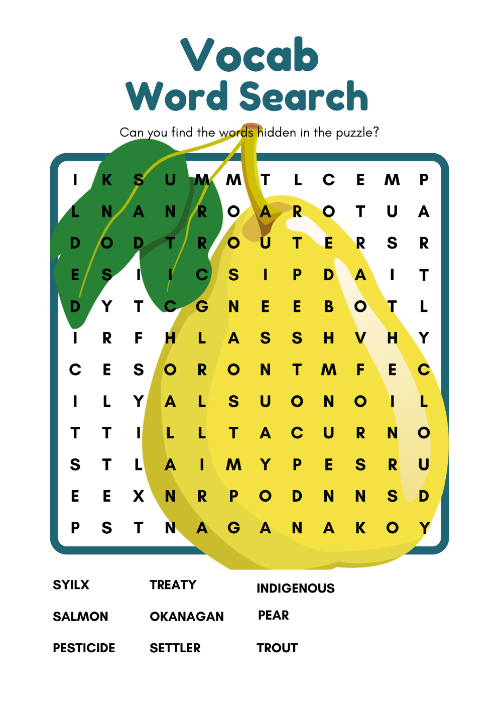
Add more vocabulary words!
Sample is too easy!

Double check spelling!

Answers will vary.

Activity F: Taking Notes
(Page 9 in student workbook)

While watching the video, take detailed notes.
Answers will vary.

Activity G: Comprehension Questions
(Page 10-11 in student workbook)

Read and answer the following questions.
Share your answers with a classmate or in small groups.

- What fruit did the Indigenous, Syilx, people intentionally plant and harvest?
  - Apples, peaches, and apricots
  - Saskatoon berries and sumac berries
  - Cherries, plums, and pears

- What is one challenge that Okanagan orchard farmers face in terms of pests?
  - Apples maggot
  - Codling moth
  - Both a and b

- What are some methods used to address pest challenges in orchards?
- Pesticides and fungicides
- Plastic owls and scarecrows
- Both a and b

- Who was the first group of people who started small scaled orchards in the Okanagan? And what kind of fruit were they growing?
- The European settler and apples
- The Syilx people and Saskatoon berries
- The Syilx people and Sumac berries

- What are water flumes?
- a wooden or metal channel that is used to transport water
- a watering system used for irrigation
- Both a and b

- What is another name for Kelowna?
- The Garden city
- The Orchard heaven
- The Orchard City
- Both a & c

- What is another name for Kelowna?
- Salmon had nowhere to rest or spawn
- Indigenous people of Okanagan (Syilx) had less salmon in their diets
- Increase in water temperature & climate change
- All of the above

- How did the Syilx people use Saskatoon berries (Siya)?
- Trained the stems and branches to grow straight for arrow making
- They would make baskets out of them
- They would dry them and eat them over the winter
- Both a and c
- All of the above

- Why was the mission creek straightened?
- Because it was good for the salmon & trout
- it made it easier to build houses
- it made it easier to build golf courses
- Both b & c

Activity H: Reflection Questions
(Page 12 in student workbook)

After viewing the video, get into small groups of 2-3 and discuss the questions below.

What are the economic benefits of orchards to a region? Consider how they might contribute to a local economy.

- What do you think is the most important orchard crop in Okanagan Valley and why?
Answers will vary.

- In what ways do orchards impact the ecosystem and local biodiversity?
Answers will vary.

- What role do you think orchards play in preserving agricultural heritage and connecting people to nature?
Answers will vary.

- How do you think the weather and the climate in Kelowna affect the growth of fruits and vegetables in orchards?
Answers will vary.

Activity I: Research activity
(Page 12-14 in student workbook)

Select one of the three options provided below and conduct research to answer the questions.

OPTION #1: With a classmate, choose one of the following orchards from the Okanagan Valley:
- Twin Oaks Organic Orchard
- Arndt orchards
- Bella Rosa Orchards

Research the following:
- What products and services do they sell?
- Where are their products shipped from and to?
- When was it established?
- What makes this orchard unique/popular?
- Do they list prices online? If so, how much?
- Where can you purchase their product(s)?
Answers will vary.

OPTION #2: Write your own Land acknowledgment (you heard a land acknowledgment at the beginning of the video) and think about the following questions:
  - List of questions:
- Define your identity: Where do you come from? What languages do you speak? Are you a sister, father, son, aunt, student, teacher, volunteer, etc.?
- Who were the first settlers/peoples where you come from?
- What do you appreciate about the land where you grew up?
- Where are you now? Who are the Indigenous people’s lands that you reside on today?
- What are you grateful for about the land that you currently reside on?
- Do you feel you have a relationship with the land where you are or where you come from? What can you do to learn more about the ecosystem and land that you are on?
- What is one thing you can commit to as a way of learning about the Indigenous people here or helping care for this land?

  - Share your land acknowledgment with a classmate or small group.
Answers will vary.

OPTION #3: Research a kind of fruit from your home country and find out some interesting facts about it such as:

- What region & climate does it grow in?
- When is it planted and is harvested?
- How is it packed & shipped? (Where does this happen?)
- Do farmers require any special tools for planting, watering, or harvesting?
- What types of sprays are used to help keep it safe from pests & diseases? Are any of these sprays organic?
- Do places in your home country advertise their product for tourism or events like the orchard industry in Canada? Why do you think they might or might not?
Answers will vary.

