The Billionaire Space Race:
A New Era of Private Spaceflight & Tourism
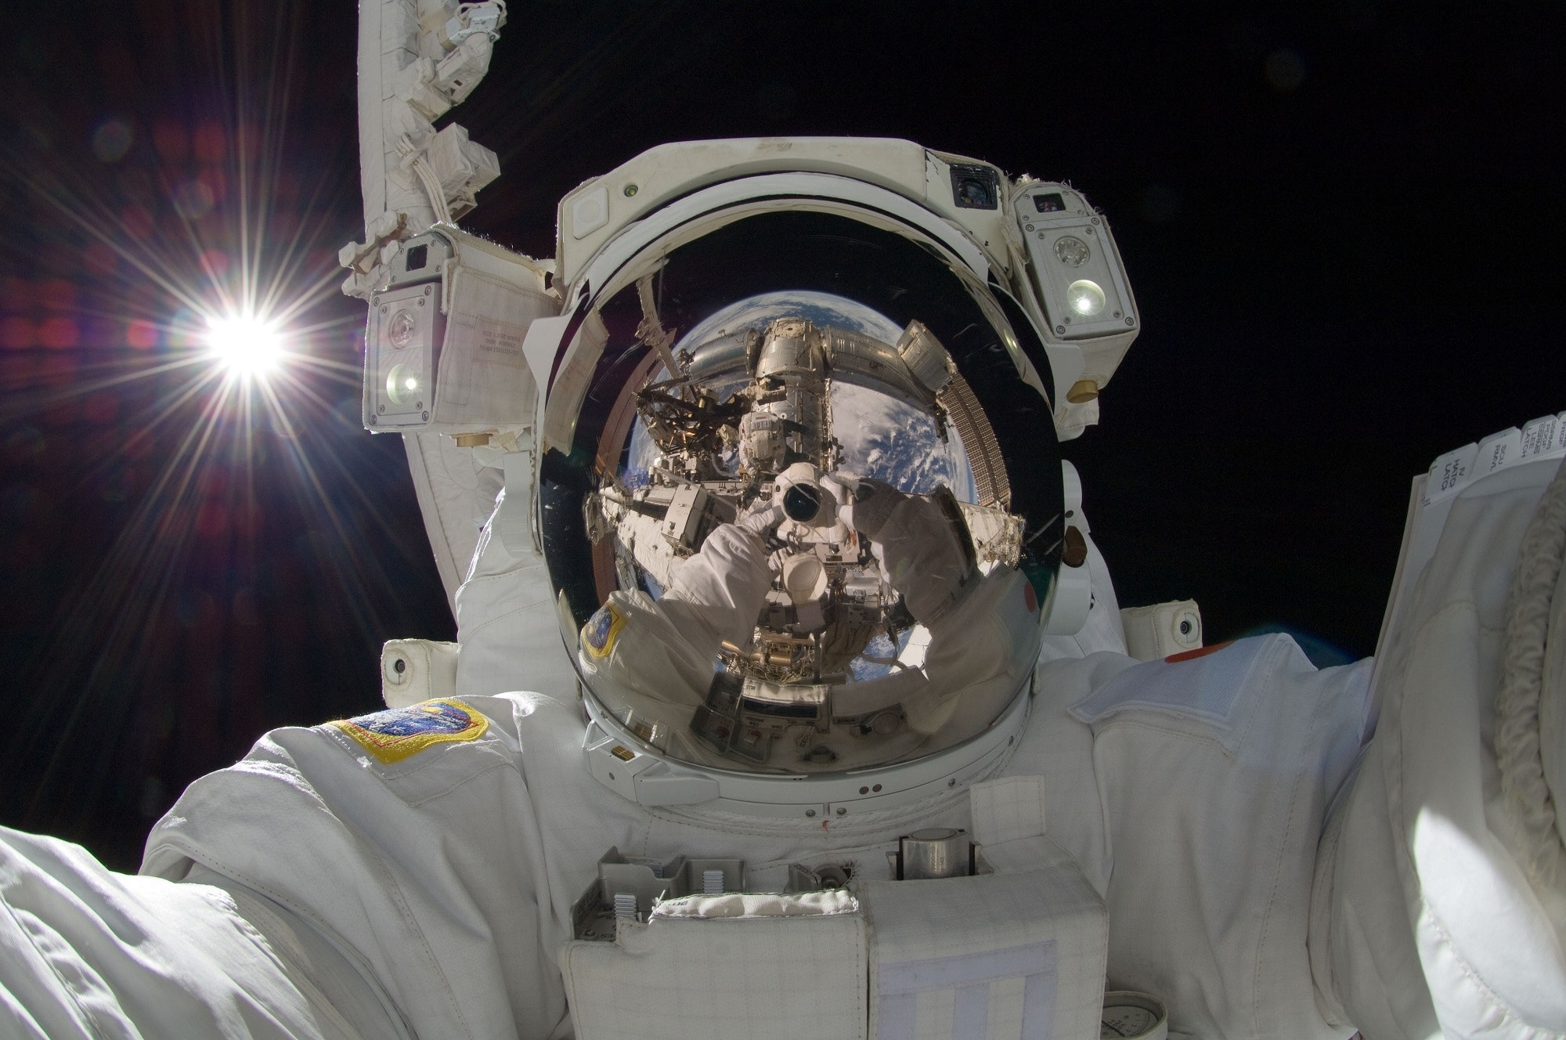
Student Workbook
Marcus Bucek

The Billionaire Space Race: Listening and Speaking Level III
Post Secondary Education Skills: Upper Intermediate English
(cc) Marcus Bucek and the University of British Columbia’s Okanagan School of Education 2022
This work is licensed under a Creative Commons Attribution-Non-commercial-ShareAlike 4.0 International License.

Under the terms of the license, you are free to:
Share—copy and redistribute the material in any medium or format
Adapt—remix, transform, and build upon the material The licensor cannot revoke these freedoms as long as you follow the license terms.
Under the following terms:
Attribution — You must give appropriate credit, provide a link to the license, and indicate if changes were made. You may do so in any reasonable manner, but not in any way that suggests the licensor endorses you or your use.
NonCommercial — You may not use the material for commercial purposes.
ShareAlike — If you remix, transform, or build upon the material, you must distribute your contributions under the same license as the original.
Director, EAL Programs: Dr. Scott Roy Douglas
Program Coordinator, EAL Programs: Amber McLeod
Author: Marcus Bucek
Design: Ashley Johnston
Writers : Marcus Bucek, Amber McLeod, Ashley Johnston
This project was funded, in part, by the UBC Okanagan Open education Resources Grant Program.
Published by: English as an Additional Language Programs,
Okanagan School of Education, University of British Columbia,
1137 Alumni Avenue, Kelowna, British Columbia V1V 1V7
The photographs and artwork used in these materials may not be altered in any way without permission from the copyright holder, all information is listed on page 21.

Contents
Activity A1: Discussions 3
Activity A2: Private Spaceflight & Tourism Discussion 5
Activity B1: Vocabulary Definitions 6
Activity B2: Complete the Sentence 8
Activity C1: Video - Private Spaceflight & Tourism 11
Activity C2: Comprehension Questions 12
Activity D: Phrasal Verbs & Expressions 14
Activity E: Making Predictions 16
Activity F: Reflection & Extension Activities 17
Photo Credits 21

Activity A1: Discussions

Introduction to Outer Space - Think/Pair/Share:

Discuss some of the following questions with a partner (2-3min) and then in groups of 3-4 (3-4min). Be ready to briefly share your answers with the class. You may want to use the next page to take notes.

Notes:

Activity A2: Private Spaceflight & Tourism Discussion

Think about the following questions and then discuss with a partner (or a group of 3-4). Take some brief notes on your own thoughts and others’.
(Hint: you will need them for a later activity!).

- What are some advantages and disadvantages of private spaceflight programs?
- Who might benefit from the privatization of space and who might suffer? Why?
- Should private companies be allowed to own property in space or in the solar system - why or why not?
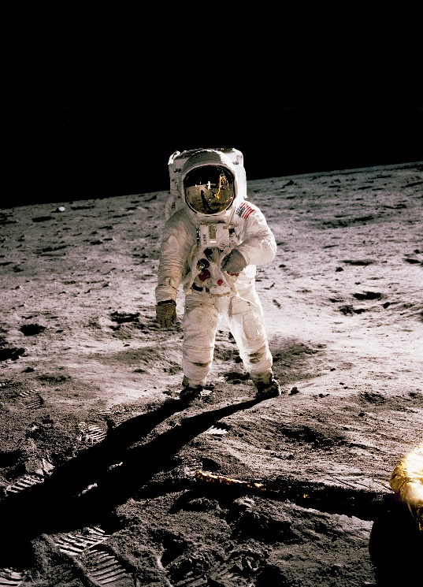
Notes:

Activity B1: Vocabulary Definitions
Discuss the possible meaning of each word with a partner. Then, look it up in an English dictionary and write it in your own words.
Term | Definition
Aerospace (n)

Accountable (adj)

Commonplace (adj)

Debris (n)

Deregulation (n)
Endeavour (n)
Inequality (n)

Incentive (n)

Lift off (phrasal verb)

Low Earth Orbit

Lucrative (adj)

Multiplanetary (adj)

Payload (n)
Reusable (adj)
Weightlessness (n)

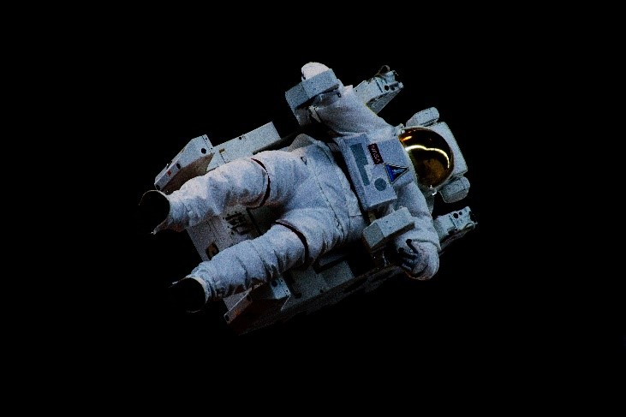

Activity B2: Complete the Sentence

Select the correct definition to fill in the blank.
- Private spaceflight has gone from being a dream to becoming a __________ deal for private aerospace companies in the past ten years.
- popular b. lucrative c. Imaginary
- Before ______________ in the 1990’s, spaceflight was reserved for government agencies and their trained astronauts (usually military or civilian scientists).
  - deregulation b. globalization c. privatization
- Private ___________ companies are hoping to have contracts for NASA, the military and the International Space Station, while government funded programs focus on more ambitious missions (such as returning to the Moon or sending astronauts to Mars).
- interstellar b. research c. aerospace
- NASA-contracted commercial companies like SpaceX are using _________rockets and spacecrafts (that can land vertically and be used again) to send crew and supplies to the International Space Station.
a. reusable b. Russian c. multiplanetary
- The space tourism industry has literally taken off. Space tourists are starting to pay over several million dollars per ticket for a seat on a spacecraft flight where they can go up and experience short term ________________ in low earth orbit.
a. weightlessness b. gravity c. missions

- There’s enormous potential for the development of a diverse economy to emerge from space privatization and become ___________ as everyday infrastructure such as banking, railroads, airlines and computers.
- accessible b. commonplace c. commercial
- While there are many positive financial __________ for private spaceflight, some have criticized the development as only benefiting the wealthy and the elite.
a. incentives b. risks c. advantages
- Some see the new “billionaire space race” as a reflection of the vast wealth ___________ that exists on Planet Earth among peoples and nations. Especially when the richest individuals like Amazon/Blue Origin’s Jeff Bezos & Elon Musk of SpaceX are at the top of this pyramid.
- inequality b. supply c. distribution
- Musk has defended his work, stating he hopes to get humans to Mars one day and turn humanity into a _____________ civilization to ensure our continued survival.
a. Multigenerational b. multiplanetary c. computer-simulated
- While previous space programs were publicly and federally ____________, the question raised with private spaceflight is “who do private space companies answer to?”
a. Owned b. accountable c. responsible
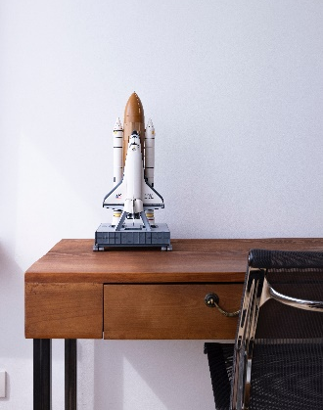
- Another problem with private spaceflight is the amount of carbon released into the atmosphere during _______. This is not good for human carbon emissions in terms of the increasing risk of climate change.
a. Touchdown b. lift off c. departure.

- Furthermore, all that private _________ in orbit could hit nearby government satellites, spacecrafts and stations. This could seriously damage important functions needed back on Earth (such as weather monitoring and communications).
  - dust b. fuel c. debris
- One prediction is that with more private competition, the overall costs to send ________ into orbit will be reduced.
- animals b. payload c. equipment
- Instead of flying lots of people into space as tourists, one prediction is that more individuals and groups will be able to invest in companies that are capable of launching payloads not too high up into ___________ .
- atmosphere b. ocean c. low earth orbit
- While the impact of private spaceflight may still be up for debate, hopefully the innovations required for and developed from these bold ____________ will widely benefit many people back here on Earth.
  - endeavors b. designs c. benefits

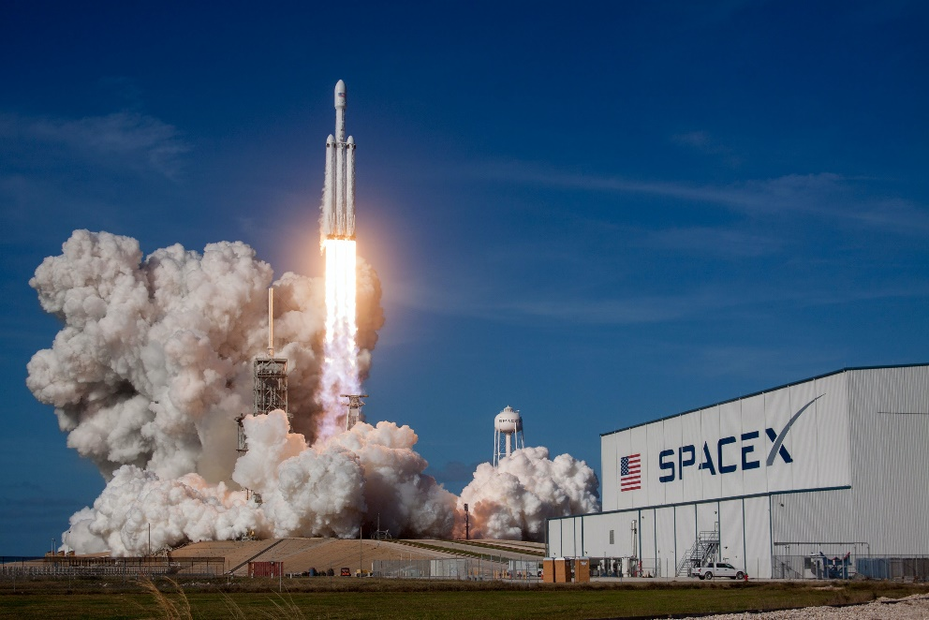

Activity C1: Video - Private Spaceflight & Tourism

- Before you watch the video, read the comprehension questions in Activity C2. Chat with a partner about the first 3-5 questions and share your thoughts, ideas or further questions you may have.
- Watch the video and use the chart below to take some notes about the main points, supporting details, and also any personal thoughts/ideas/questions that come to mind.
Personal thoughts & questions on the video | Main points & Details

Activity C2: Comprehension Questions

After watching the video, reread and answer the following questions below.
- What is one fundamental purpose for spaceflight & exploration?
- Name 2-3 significant past achievements in space from the past 65 years.
- Who are some of these private space companies?
- What are some goals that private space programs hope to one day achieve?
- Give an example of what SpaceX is doing in orbit.
- What is one prediction about what private spaceflight could lead to?
- List 2-3 questions from the talk that discuss the concerns related to private spaceflight.
- What are the advantages and disadvantages of private spaceflight programs?
- [Optional Extension] Using your notes and earlier discussion, write your own question related to the content in the video. Then, exchange with a partner. Answer each other’s question with a main reason (or two) and details (see structure below & graphic organizer on next page). Be prepared to share with a small group.
Possible Examples:
- “What kind of people should be given approval and priority to privately fly into space?
- “How might we use private spaceflight to reduce the effects of climate change?”
- “What kind of laws might be needed to regulate private spaceflight for safety, security and success for all?”
Structuring an Argument:
Argument
Reason 1:
Details/Examples:
Reason 2:
Details/ Examples
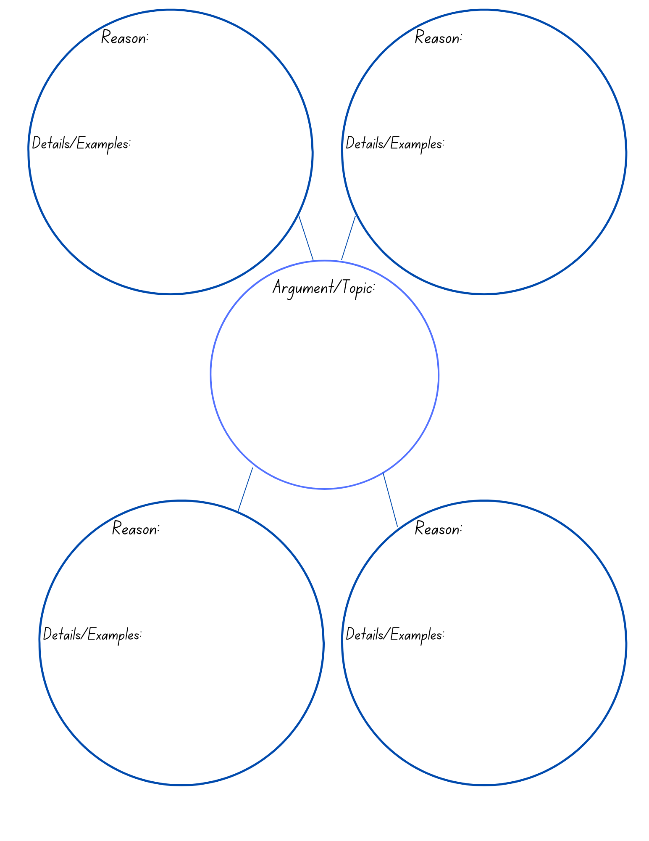

Activity D: Phrasal Verbs & Expressions

Use the phrasal verbs and expressions below to fill in the blanks of the following sentences. (See next page for sentences)
- Take/Lift off → 1. launch
- Soar upwards → 2. fly up
- Start-up/out → 3. get going / begin with
- Get off the ground → 4. begin / rise / start with
- Shift attention to/on → 5. refocus / switch focus to/on
- Jury’s still out → 6. the answers are still up for discussion
- Keep an eye on → 7. watch for
- Scaled back → 8. do less of / reduce work on
- Push ourselves → 9. keep going and don’t give up
- Rely on → 10. be dependent upon
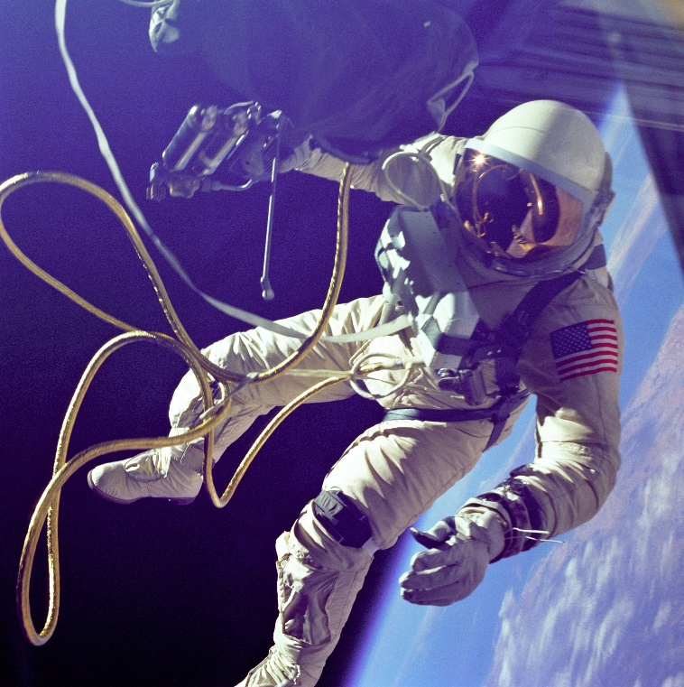

- We really __________ the Russians for trips to the International Space Station since we don’t have the space shuttle anymore.
- We have no idea whether private spaceflight will be good for the majority of societies back on Earth or if it’ll only benefit a few people. In a sense the ______________ on giving a concrete answer.
- Without enough donors or investors, there is no way our private rocket will literally _______________ and fly into space.
- We’ve had to ____________ production and slow down delivery of units due to safety concerns.
- If we keep going, don’t give up and ultimately ______________, there’s little reason we can’t achieve our objectives.
- Okay, if you can ___________________ this film here - I think you’ll find what it shows to be quite interesting.
- In the beginning, don’t expect to make any money - ___________ companies usually need to invest in themselves before others invest in them.
- The government should ______________ private spaceflight activities so officials know what impact space commercialization will have on the planet and society at large.
- In order to _____________ to new heights with our reusable spaceplane, the number of investors needs to reach new heights as well.
- _________ from Virgin Galactic’s spaceport begins with a flight under a mothership before the rocket motors are fired for the climb into low earth orbit.

Activity E: Making Predictions

- Look below at the questions that ask about hypothetical outcomes related to the subject of private spaceflight.
- Individually, think about and write out a possible prediction based on what you think could happen (i.e., if space privatization is without regulation by governments or a space hotel is opened). How might it start, what will the effect/impact be and what could be done in response?
- Be ready to share with at least 2 other people in a small group. Be sure to include
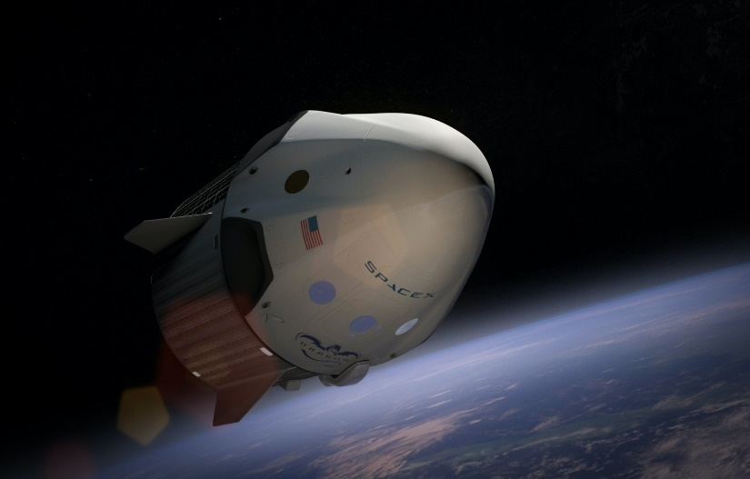
- Supporting reasons with details/examples
- 2-3 vocabulary terms from the unit
- Paraphrasing, Grammar or other Study & Research Tips!
Example: What might happen if …
- …a space hotel is opened - who might visit and for what reasons?
- …a foreign country accuses a private space mission of spying over their territory?
- …an accident causes space debris from a private satellite to hit a critical communications satellite or government spacecraft / station?
- …the world’s first private space tourist touches down on the moon - what could this mean, legally?
- …Choose & create your own

Activity F: Reflection & Extension Activities

Choose one of the following activities independently or with a partner (options 1-3).
Option #1. Critical Thinking - Agree or Disagree Scale: (Step 1 – 5)
- Get into small groups. In your group, work to create one sentence or statement that you collectively believe about the subject from your Activity 2: Private Spaceflight & Tourism. Submit these sentences / statements into a class folder.
Example: We believe that private spaceflight - while innovative and adventurous - is not overall helpful to most of society on Earth.
- Next, have one person from your group randomly pick a sentence or statement from the submissions to the class folder.
- Collectively discuss how strongly your group agrees or disagrees with the sentence/statement, and place your group’s choice on a scale (as seen below). Support your group’s reasoning with details/examples (see structure on ELL Tips sheet). You can include paraphrasing and/or reported speech and ideally should utilize 2-3 vocabulary terms.
- Share your group’s chosen statement and reason for its placement on the scale with the rest of the class. You should ideally share and present with a minimum of 3 other groups to hear their statements and reasons for why they agree/disagree.
- Extension: Rewatch the video and look at your original statements and their placement on the scale. Adjust and modify them if needed. How has the video changed your perspective.

Option #2. Pro’s & Con’s (A&B)

- How has spaceflight & exploration impacted your life? Work with a partner and discuss how you have benefited from space travel or exploration. Look up some examples online (including YouTube) & list them below:

Next…

- Choose one development from spaceflight & exploration and discuss why you value it the most and how your life might be different without it. Be ready to share with the other partners in class. Use the chart on the next page to help you.

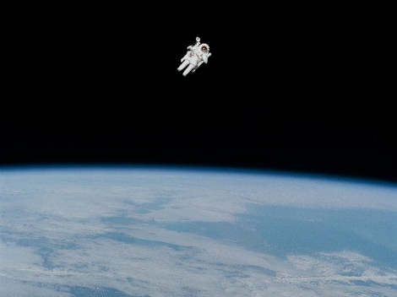
Space Activity / Technology | Positive / Negative Impact | Example (if relevant)
Example:  Private space hotel | It will allow for more people to visit space for scientific, medical or exploratory reasons. However, it will be expensive and not everyone on Earth may benefit from work done up there. | Jeff Bezos’ plans for Orbital Reef
Option #3. Role Playing Activity:
One person is defending their private commercial space flights against a panel of concerned government officials on a Commission for Privatized Space Safety.
Person A is the “Private Space Industrialist” and Persons B-D ask questions and provide challenges to Person A (who must provide answers and justifications for their private space program & commercial activities).
Share & present to the class (5 min. max).

Photo Credits

Cover Page: Photo by Pixabay on Pexels
Page 4: Photo by Space X on Unsplash
Page 5: Photo by History in HD on Unsplash
Page 7: Photo by Niketh Vellanki on Unsplash
Page 9: Photo by Jean- Phillippe Delberghe on Unsplash
Page 10: Photo by Space X on Unsplash
Page 14: Photo by Pixabay on Pexels.com
Page 15: Photo by Ivan Diaz on Unsplash
Page 16: Photo by SpaceX on Pexels.com
Page 17: photo by Aldebaran S on Unsplash
Page 17: Infographic by Ashley Johnston
Page 18: Photo by Nasa on Unsplash
Page 20: Photo by William Fortunato on Pexels.com

