The Billionaire Space Race:
A New Era of Private Spaceflight & Tourism

Answer Key
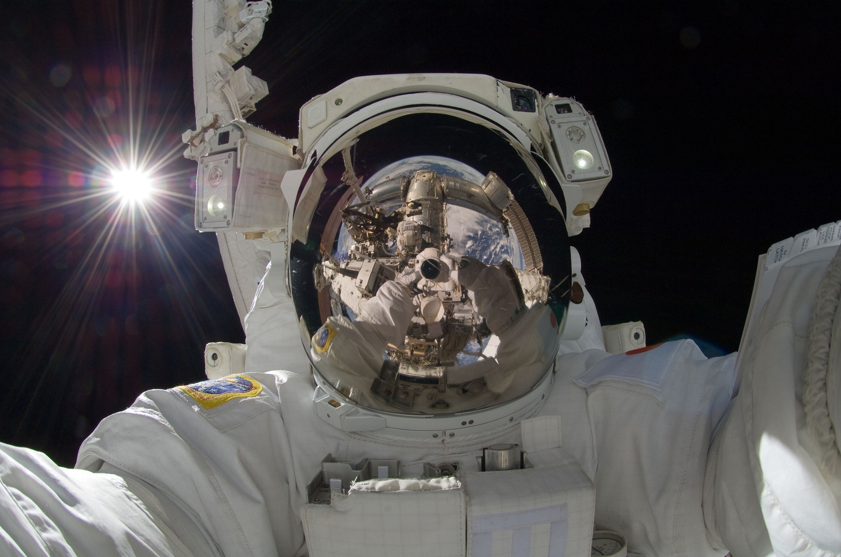

Student Workbook
Marcus Bucek

The Billionaire Space Race: Listening and Speaking Level III
Post Secondary Education Skills: Upper Intermediate English
(cc) Marcus Bucek and the University of British Columbia’s Okanagan School of Education 2022
This work is licensed under a Creative Commons Attribution-Non-commercial-ShareAlike 4.0 International License.

Under the terms of the license, you are free to:
Share—copy and redistribute the material in any medium or format
Adapt—remix, transform, and build upon the material The licensor cannot revoke these freedoms as long as you follow the license terms.
Under the following terms:
Attribution — You must give appropriate credit, provide a link to the license, and indicate if changes were made. You may do so in any reasonable manner, but not in any way that suggests the licensor endorses you or your use.
NonCommercial — You may not use the material for commercial purposes.
ShareAlike — If you remix, transform, or build upon the material, you must distribute your contributions under the same license as the original.
Director, EAL Programs: Dr. Scott Roy Douglas
Program Coordinator, EAL Programs: Amber McLeod
Author: Marcus Bucek
Design: Ashley Johnston
Writers : Marcus Bucek, Amber McLeod, Ashley Johnston
This project was funded, in part, by the UBC Okanagan Open education Resources Grant Program.
Published by: English as an Additional Language Programs,
Okanagan School of Education, University of British Columbia,
1137 Alumni Avenue, Kelowna, British Columbia V1V 1V7
The photographs and artwork used in these materials may not be altered in any way without permission from the copyright holder, all information is listed on page 21.

Contents
Activity A1: Discussions 4
Activity A2: Private Spaceflight & Tourism Discussion 4
Activity B1: Vocabulary Definitions 5
Activity B2: Complete the Sentence 6
Activity C1: Video - Private Spaceflight & Tourism 8
Activity C2: Comprehension Questions 9
Activity D: Phrasal Verbs & Expressions 12
Activity E: Making Predictions 13
Activity F: Reflection & Extension Activities 14

Activity A1: Discussions
(Page 3-4 in student workbook)
Introduction to Outer Space - Think/Pair/Share:
Discuss some of the following questions with a partner (2-3min) and then in groups of 3-4 (3-4min). Be ready to briefly share your answers with the class. You may want to use the next page to take notes.

- What comes to mind when you hear the words spaceflight or space exploration? Answers will vary.
- What fundamental needs do you think spaceflight & exploration serve? Reflect on the effects & benefits of space exploration using the question words (5W+H) Answers will vary.
- What are some significant turning points or developments in the history of space exploration and why (i.e, why was Apollo 11 or the International Space Station significant)? Answers will vary.
- Can you name any famous astronauts from your home country or overseas? What did they do up in space? Answers will vary.
- What do you think of when you hear the words private spaceflight or space tourism? Answers will vary.
- Would you take a multimillion-dollar trip to space - why or why not? Answers will vary.

Activity A2: Private Spaceflight & Tourism Discussion
(Page 5 in student workbook)
Think about the following questions and then discuss with a partner (or a group of 3-4). Take some brief notes on your own thoughts and others’.
(Hint: you will need them for a later activity!).

- What are some advantages and disadvantages of private spaceflight programs? ANSWERS WILL VARY
- Who might benefit from the privatization of space and who might suffer? Why? ANSWERS WILL VARY
- Should private companies be allowed to own property in space or in the solar system - why or why not? ANSWERS WILL VARY

Activity B1: Vocabulary Definitions
(Page 6-7 in student workbook)
Discuss the possible meaning of each word with a partner. Then, look it up in an English dictionary and write it in your own words.

Term | Definition (taken from Oxford Learner’s Dictionary)
Aerospace (n) | the industry of building aircraft, vehicles and equipment to be sent into space
Accountable (adj) | responsible for your decisions or actions and expected to explain them when you are asked
Commonplace (adj) | done very often, or existing in many places, and therefore not unusual
Debris (n) | pieces of wood, metal, building materials, etc. that are left after something has been destroyed
Deregulation (n) | ​the process of making a trade, business activity, etc. free from rules and controls
Endeavour (n) | an attempt to do something, especially something new or difficult
Inequality (n) | the unfair difference between groups of people in society, when some have more wealth, status or opportunities than others
Incentive (n) | (for/to somebody/something) (to do something) something that encourages you to do something
Lift off (phrasal verb) | to leave the ground and rise into the air
Low Earth Orbit | In orbit around the Earth close to the Earth’s surface (not an extremely high altitude)
Lucrative (adj) | producing a large amount of money; making a large profit
Multiplanetary (adj) | Being from, or a part of many planets.
Payload (n) | the passengers or goods on a vehicle, especially an aircraft, for which payment is received
Reusable (adj) | Can be used multiple times
Weightlessness (n) | the fact of having or appearing to have no weight, for example because there is no gravity

Activity B2: Complete the Sentence
(Page 8-10 in student workbook)
Select the correct definition to fill in the blank.
- Private spaceflight has gone from being a dream to becoming a lucrative deal for private aerospace companies in the past ten years.
  - popular b. lucrative c. Imaginary

- Before deregulation in the 1990s, spaceflight was reserved for government agencies and their trained astronauts (usually military or civilian scientists).
  - deregulation b. globalization c. privatization

- Private Aerospace companies are hoping to have contracts for NASA, the military and the International Space Station while government funded programs focus on more ambitious missions (such as returning to the Moon or sending astronauts to Mars).
  - interstellar b. research c. aerospace

- NASA-contracted commercial companies such as SpaceX are using reusable rockets and spacecraft (that can land vertically and be used again) to send crew and supplies to the International Space Station.
a. reusable b. Russian c. multiplanetary

- The space tourism industry has literally taken off. Space tourists are starting to pay over several million dollars per ticket for a seat on a spacecraft flight where they can go up and experience short term weightlessness in low earth orbit.
  - weightlessness b. gravity c. missions

- There’s enormous potential for the development of a diverse economy to emerge from space privatization and become commonplace as everyday infrastructure such as banking, railroads, airlines and computers.
  - Accessible b. commonplace c. commercial

- While there are many positive financial incentives for private spaceflight, some have criticized the development as only benefiting the wealthy and the elite.
  - incentives b. risks c. advantages

- Some see the new “billionaire space race” as a reflection of the vast wealth inequality that exists on Planet Earth among peoples and nations. Especially when the richest individuals like Amazon/Blue Origin’s Jeff Bezos & Elon Musk of SpaceX are at the top of this pyramid.
  - inequality b. supply c. distribution

- Musk has defended his work, stating he hopes to get humans to Mars one day and turn humanity into a multiplanetary civilization to ensure our continued survival.
  - Multigenerational b. multiplanetary c. computer-simulated

- While previous space programs were publicly and federally accountable, the question raised with private spaceflight is “who do private space companies answer to?”
  - owned b. accountable c. responsible

- Another problem with private spaceflight is the amount of carbon released into the atmosphere during lift off. This is not good for human carbon emissions in terms of the increasing risk from climate change.
  - Touchdown b. lift off c. departure

- Furthermore, all that private debris in orbit could hit nearby government satellites, spacecraft and stations. This could seriously damage important functions needed back on Earth (such as weather monitoring and communications).
  - dust b. fuel c. debris

- One prediction is that with more private competition, the overall costs to send payload into orbit will be reduced.
  - animals b. payload c. equipment

- Instead of flying lots of people into space as tourists, one prediction is that more individuals and groups will be able to invest in companies that are capable of launching payloads not too high up into low earth orbit.
  - atmosphere b. ocean c. low earth orbit

- While the impact of private spaceflight may still be up for debate, the innovations required for and developed from these bold endeavors will hopefully widely benefit many people back here on Earth.
  - Endeavors b. designs c. benefits

Activity C1: Video - Private Spaceflight & Tourism
(Page 11 in student workbook)
- Before you watch the video, read the comprehension questions in Activity C2. Chat with a partner about the first 3-5 questions and share your thoughts, ideas or further questions you may have.
- Watch the video and use the chart below to take some notes about the main points, supporting details, and also any personal thoughts/ideas/questions that come to mind.
Personal thoughts & questions on the video | Main points & Details
ANSWERS WILL VARY | ANSWERS WILL VARY

Activity C2: Comprehension Questions
(Page 12 – 13 in student workbook)
After watching the video, reread and answer the following questions.

- What is one fundamental purpose of spaceflight & exploration?
- To understand & explore our environment and help Humanity improve life through technological and scientific studies & developments.

- Name 2-3 significant past achievements in space from the past 65 years
- Sputnik, Yuri Gagarin, Apollo 11, the Space Shuttle, Space Station Mir and the International Space Station

- Who are some of these private space companies?
- Elon Musk’s SpaceX, Richard Branson’s Virgin Galactic & Jeff Bezos’ Blue Origin

- What are some goals that private space programs hope to one day achieve?
- Space tourism & flights into orbit; Private space station & hotel; missions to and colonies on Mars; asteroid mining; connect remote areas on Earth to the internet via satellites (Starlink).

- Give an example of what SpaceX is working on / doing in orbit.
- Sending supplies and astronauts to the ISS; providing greater internet connectivity via Starlink, designing reusable rockets/spacecraft (i.e. “Starship”) for future missions; planning and building a multiplanetary civilization on Mars.

- What is one prediction about what private spaceflight could lead to?
- Greater competition → more technological innovation→ lowering of costs→ greater accessibility.
- More people / companies investing in institutions that have some work / activities done in space.
- List 2-3 questions related to the talk that discuss the concerns related to private spaceflight
- How will all the private launches contribute to carbon emissions and climate change?
- Who will these private companies answer to if something goes wrong?
- Why do this when we have more serious issues and problems on Earth to solve?

- What are the advantages and disadvantages of private spaceflight programs?
- Pros: Private spaceflight can be done cheaper and quicker than the government; more investment and opportunities for low earth orbit; more people can appreciate the Earth from above; more technological benefits for people back on Earth (i.e. monitor changes on Earth and prepare for disaster)
- Cons: Right now only for the extremely rich and the elite; money could be better spent solving problems on Earth (i.e. wealth inequality); burning fuel from launches adds to carbon in atmosphere (increasing climate change); possible risk of collision between private spacecraft and government property - could impact life on Earth significantly.
- [Optional Extension] Using any of your notes and earlier questions discussed, write your own question related to the content in the video. Then, exchange with a partner. Answer and exchange each others’ question with a main reason (or two) and details (see structure below). Be prepared to share with a small group.
Possible Examples:
- “What kind of people should be given approval and priority to privately fly into space - and why?”
- “How might we use private spaceflight to reduce the effects of climate change?”
- “What kind of laws might be needed to regulate private spaceflight for safety, security and success for all?”

Structuring an Argument: ANSWERS WILL VARY
Argument:
Reason:
Details/Examples:
Reason:
Details/ Examples:

Activity D: Phrasal Verbs & Expressions
(Page 14 -15 in student workbook)
Use the phrasal verbs and expressions to fill in the blanks of the following sentences.

- Take/Lift off → 1. launch
- Soar upwards → 2. fly up
- Start up/out → 3. get going / begin with
- Get off the ground → 4. begin / rise / start with
- Shift attention to/on → 5. refocus / switch focus to/on
- Jury’s still out → 6. the answers are still up for discussion
- Keep an eye on → 7. watch for
- Scaled back → 8. do less of / reduce work on
- Push ourselves → 9. keep going and don’t give up
- Rely on → 10. be dependent upon

- We really [Rely on] the Russians for trips to the Space Station since we don’t have the space shuttle anymore.
- We have no idea whether private spaceflight will be good for the majority of societies back on Earth or if it’ll only benefit a few people. In a sense the [Jury’s still out] on giving a concrete answer.
- Without enough donors or investors, there is no way our private rocket will literally [get off the ground] and fly into space.
- We’ve had to [scale back] production and slow down delivery of units due to safety concerns.
- If we keep going, don’t give up and ultimately [push ourselves], there’s little reason we can’t achieve our objectives.
- Okay, if you can [shift attention to] this film here - I think you’ll find what it shows to be quite interesting.
- In the beginning, don’t expect to make any money - [start up] companies usually need to invest in themselves before others invest in them.
- The government should [keep an eye on] private spaceflight activities so officials know what impact space commercialization will have on the planet and society at large.
- In order to [soar upwards] to new heights with our reusable spaceplane, the number of investors needs to reach new heights as well.
- Take off] from Virgin Galactic’s spaceport begins with a flight under a mothership before the rocket motors are fired for the climb into low earth orbit.

Activity E: Making Predictions
(Page 16 in student workbook)
- Look below at the questions that ask about hypothetical outcomes related to the subject of private spaceflight.
- Individually, think about and write out a possible prediction based on what you think could happen (i.e., if space privatization is without regulation by governments or a space hotel is opened). How might it start, what will the effect/impact be and what could be done in response?
- Be ready to share with at least 2 other people in a small group. Be sure to include:
- Supporting reasons with details/examples
- 2-3 vocabulary terms from the unit
- Paraphrasing, Grammar or other Study & Research Tips!

Example: What might happen if …
- …a space hotel is opened - who might visit and for what reasons?
- …a foreign country accuses a private space mission of spying over their territory?
- …an accident causes space debris from a private satellite to hit a critical communications satellite or government spacecraft / station?
- …the world’s first private space tourist touches down on the moon - what could this mean, legally?
- …[Choose & create your own!]
ANSWERS WILL VARY

Activity F: Reflection & Extension Activities
(Page 17 -20 in student workbook)
Choose to engage in one of the following reflection/extension activities (either independently or with a partner).

Option #1. Critical Thinking - Agree or Disagree Scale
- Get into small groups. In your group, work to create one sentence or statement that you collectively believe about the subject from your second activating prior knowledge discussion activity (Private Spaceflight & Tourism). Submit these sentences / statements into a class folder.
Example: We believe that private spaceflight - while innovative and adventurous - is not overall helpful to most of society on Earth.
- Next, have one person from your group randomly pick a sentence/statement from the submissions to the class folder.
- Collectively discuss how strongly your group agrees or disagrees with the sentence/statement, and place your group’s choice on a scale (as seen below). Support your group’s reasoning with details/examples (see structure on ELL Tips sheet). You can include paraphrasing and/or reported speech and ideally should utilize 2-3 vocabulary terms.
- Share your group’s chosen statement and reason for its placement on the scale with the rest of the class. You should ideally share and present with a minimum of 3 other groups to hear their statements and reasons for why they agree/disagree.
- Extension: Rewatch the video and look at your original statements and their placement on the scale. Adjust and modify them if needed. How has the video changed your perspective?
ANSWERS WILL VARY

Option #2. Pros & Cons: (Page 18 in student workbook)
- How has spaceflight & exploration impacted your life? Work with a partner and discuss how you have benefited from space travel or exploration. Look up some examples online (including YouTube).
- Choose one significant technological invention or development from spaceflight & exploration - and discuss why you value it the most and how your life might be different without it. Be ready to share with the other partners in class. Use the chart below to help plan your answers.

ANSWERS WILL VARY
Space Activity / Technology | Positive / Negative Impact | Example (if relevant)
Private space hotel | It will allow for more people to visit space for scientific, medical or exploratory reasons. However, it will be expensive and not everyone on Earth may benefit from work done up there. | Jeff Bezos’ plans for the private space station Orbital Reef in 2030.

Option #3. Role Playing Activity:
One person is defending their private commercial space flights against a panel of concerned government officials on a Commission for Privatized Space Safety.

Person A is the “Private Space Industrialist” and Persons B-D ask questions and provide challenges to Person A (who must provide answers and justifications for their private space program & commercial activities).

Share & present to the class (5 min. max).

ANSWERS WILL VARY

Additional Resources
- Billionaire Space Race - Global News
- Heliosphere (Youtube) - How Private Companies will Revolutionize Spaceflight
- Private Spaceflight Explained - Vox
- How Bad is Space Tourism? And Other Questions - Vox
- ABC News - Backlash against Bezos Spaceflight sparks Equity Debate
- Billionaires in Space - The Pros and Cons of Space Tourism
- TheHill - Will We Allow the Privatization of Space to Eclipse NASA?
- Wikipedia - SpaceX Starship

