The Origins and Branding of Indigenous World Winery
Reaching Potential: Listening and Speaking Videos
Anderson, McLeod, Moore, Scott
Reaching Potential: Listening and Speaking Videos Level IV
Post Secondary Education Skills: Upper Intermediate English
(cc) Anderson, McLeod, Moore, & Scott, & The University of British Columbia’s Okanagan School of Education 2021
This work is licensed under a Creative Commons Attribution-Non-commercial-ShareAlike 4.0 International License.

Under the terms of the license, you are free to:
Share—copy and redistribute the material in any medium or format
Adapt—remix, transform, and build upon the material The licensor cannot revoke these freedoms as long as you follow the license terms.
Under the following terms:
Attribution — You must give appropriate credit, provide a link to the license, and indicate if changes were made. You may do so in any reasonable manner, but not in any way that suggests the licensor endorses you or your use.
NonCommercial — You may not use the material for commercial purposes.
ShareAlike — If you remix, transform, or build upon the material, you must distribute your contributions under the same license as the original.

Director, EAL Programs: Scott Roy Douglas
Program Coordinator, EAP Programs: Amber McLeod
Design: Ronan Scott and Amber McLeod
Writers: Amber McLeod, Don Anderson, Nicole Moore, & Ronan Scott
This project was funded, in part, by the UBC Okanagan Open education Resources Grant Program.
Published by:
English as an Additional Language Programs
Okanagan School of Education, University of British Columbia
1137 Alumni Avenue
Kelowna, British Columbia V1V 1V7
Contents
Activity A: Discussion 4
Activity B: Vocabulary 5
Activity C: Discussion 6
Activity D: Indigenous World Winery 7
Activity F: Comprehension 9
Activity G: Critical Thinking 11
Activity H: Reflection 12
Photo Credits 13

Activity A: Discussion
Discuss the following questions with a classmate or in small groups. You can look up answers if you don’t know.

Activity B: Vocabulary

Before you watch the educational video, review the key words below.
Write a definition and example sentence for at least six of the words. Share your answers with a classmate or in small groups.
Study Tip
Got a new word? Look it up online and write a definition and example sentence to help you remember it
Key Word Definition Example
1. Alluvial Fan
2. Barrel
3. Cellar
4. Charmat Tank
5. Cultivation
6. Distillery
7. Fermentation
8. Indigenous
9. Logo
10. Sparkling wine
11. Sylix
12. Terroir
13. Vineyard
14. Vintage

Activity C: Discussion

The educational video for this unit is based on Indigenous World Winery (IWW). IWW is based in the Okanagan Valley in British Columbia. Before watching the video, look up some answers for the questions below. When you have finished, share your answers with a classmate or in small groups.

Research Tips
- Check the companies website for information
- Check review sites to get more information about the winery

Activity D: Indigenous World Winery
Read the following questions before you watch the video. Then watch the video and take notes on the next page. When you have finished, answer the questions.

- What are three characteristics about the winery business sector that you heard and remembered?

- What are two new vocabulary words that you learned in this video?

- What is an example mentioned about the wine making process or wine industry that you didn’t know before?

- What are some events or operations that Indigenous World Winery does to attract business?

- Identify three Syilx words that you hear and their meanings. Spelling does not count (Hint: think about the names of the wines and the wine toast at the end).

Watch The Origins and Branding of Indigenous World Winery video
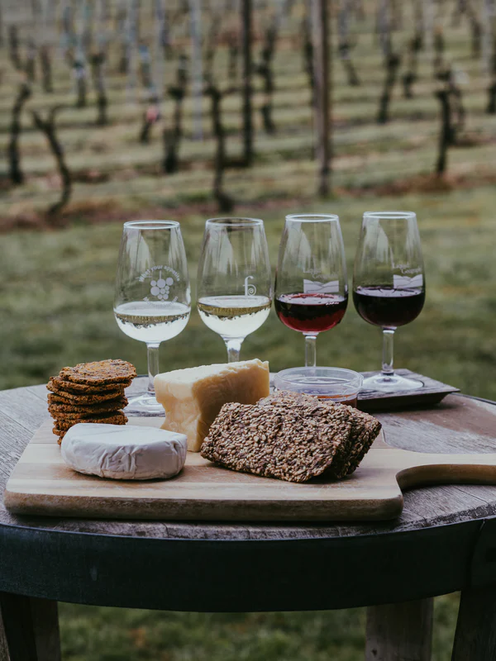
Notes

Activity F: Comprehension
Read and answer the following questions on pages 10 and 11. Share your answers with a classmate or in small groups.

- How many cases of wine does Indigenous World Winery produce a year?

- three thousand
- nine to ten thousand
- six thousand

- How many new wineries open in British Columbia a year?

- one hundred and twenty
- twenty
- two to ten

- What kind of equipment is used for making sparkling wine?

- Barrel Tank
- Yeast Tank
- Charmat Tank

- National Indigenous Peoples Day is

- June 1st
- June 21st
- January 1st

- Which of the following was mentioned as an animal image on the labels of the wine?

- Swallow
- Hawk
- Eagle

- Which of the following terroir of the valley was not mentioned in the video as something that contributes to different flavours in the wine:

- Silica
- Alluvial Fans
- Quartz
- Granite Rocks

- Rearrange these five sentences in the correct order of the winemaking process:
___ Yeast ferments the sugars in the juice
___ Wine tanks empty into the bottling line
___ Crush the grapes
___ Harvest the grapes from the vineyard
___ Fill the fermentation tanks with grapes/grape juice

Activity G: Critical Thinking

Discuss the following questions with a classmate or in small groups.

What does Ryan mean when he says you can “taste the terroir”? The quote is found in the Origins section of the video.
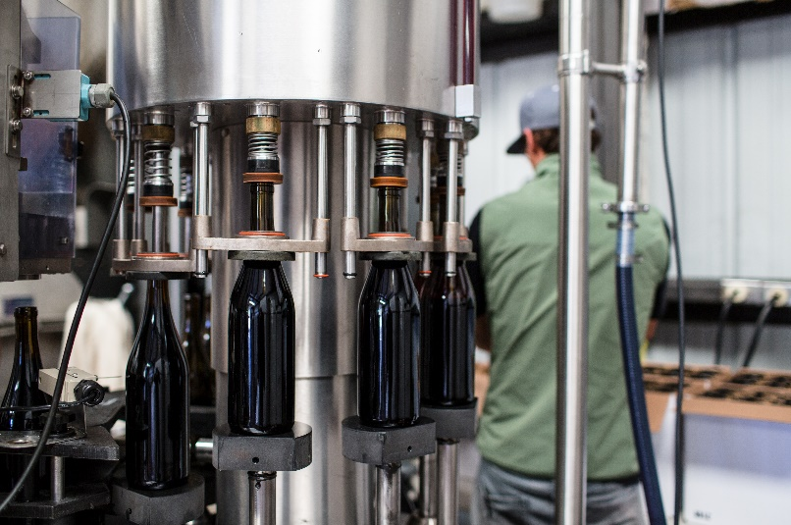

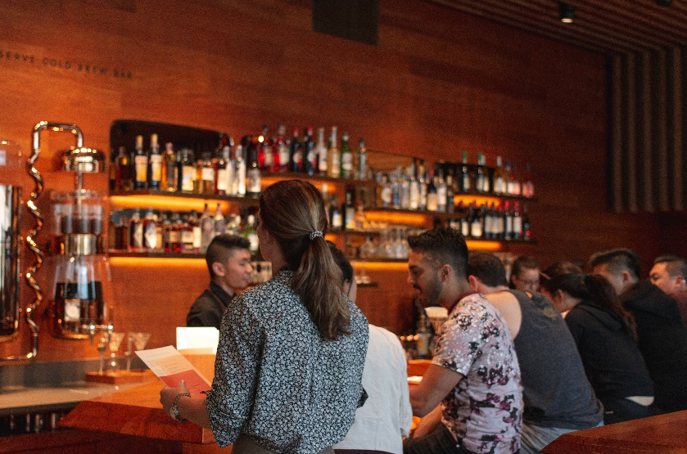

What question would you like to ask Ryan?
What would you like to hear more information on?

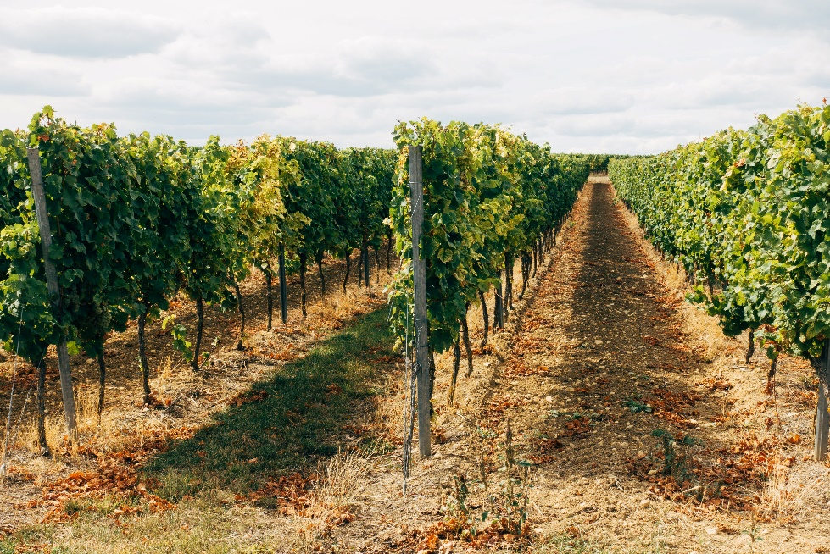

Which would you prefer, work in the vineyards and wine making process area, or work in the winery shop and bar? Explain your answer.

Activity H: Reflection

Choose one of the following reflection activities to complete with a classmate or in small groups.
Reflection 1
Share what interested you most about the winery and explain why. You can write a paragraph and then discuss with a partner.

Reflection 2
Think about what business you would like to create and what your product would be. Be sure to include your business name, logo, colours, branding, and marketing strategies. Write your business plan down. Then share your business in a small group and decide whose business you would like to invest in.

Reflection 3
National Indigenous Day is June 21st. Research online and find out what people do on National Indigenous Day.

Photo Credits

Cover Page: Photo by Jim Harris on Unsplash
Page 8: Photo by Chelsea Pridham on Unsplash
Page 5 from top down: Vindemia Winery on Unsplash ; natasha t on Unsplash; Markus Winkler on Unsplash

