Reaching Potential: Listening and Speaking Level IV
Ronan Scott
TECHNOLOGY
Reaching Potential: Listening and Speaking Level IV
Post Secondary Education Skills: Upper Intermediate English
(cc) Ronan Scott and the University of British Columbia’s Okanagan School of Education 2021
This work is licensed under a Creative Commons Attribution-Non-commercial-ShareAlike 4.0 International License.

Under the terms of the license, you are free to:
Share—copy and redistribute the material in any medium or format
Adapt—remix, transform, and build upon the material The licensor cannot revoke these freedoms as long as you follow the license terms.
Under the following terms:
Attribution — You must give appropriate credit, provide a link to the license, and indicate if changes were made. You may do so in any reasonable manner, but not in any way that suggests the licensor endorses you or your use.
NonCommercial — You may not use the material for commercial purposes.
ShareAlike — If you remix, transform, or build upon the material, you must distribute your contributions under the same license as the original.
Director, EAL Programs: Scott Roy Douglas
Program Coordinator, EAL Programs: Amber McLeod
Author and Layout: Ronan Scott
This project was funded, in part, by the UBC Okanagan Open education Resources Grant Program.
Published by:
English as an Additional Language Programs
Okanagan School of Education, University of British Columbia
1137 Alumni Avenue
Kelowna, British Columbia V1V 1V7
The photographs and artwork used in these materials may not be altered in any way without permission from the copyright holder, all information is listed on page 37.
TABLE OF CONTENTS
Discussion 5
Activity A: Discussion 5
Listening Skill: Identification 6
Activity A: Identify Key Points 6
Activity B: Discussion 7
Core Listening Vocabulary 8
Activity A: Discussion 8
Activity B: Research 9
Activity C: Listen for the Answers 10
Activity D: Create 11
Listening Text: Academic Lecture on 3D Printing 12
Activity A: Notetaking 12
Activity B: Reflection 13
Critical Thinking: 3D Printing and my Community 14
Activity A: Discussion 14
Activity B: Research 15
Activity C: Discussion 15
Grammar Skill: Using Noun Clauses and Reporting Verbs 16
Activity A: Identify the Noun Clauses 16
Activity B: Structure of Noun Clauses 17
Activity C: Noun Clauses and Reporting Verbs 18
Activity D: Reporting Verbs and Noun Clauses 18
Activity E: Using Noun Clauses to Report and Describe 19
Activity F: Research 20
Pronunciation Skill: Syllable Count and Word Stress 21
Activity A: Word Type 21
Activity B: Syllable Stress 22
Activity C: Tongue Twisters 22
Functional Speaking Skill – Agree or Disagree and Reporting Verbs 23
Activity A: What Can I Say? 23
Activity B: Which is Which? 24
Activity C: Agree or Disagree? 25
Activity D 26
Core Speaking Vocabulary 27
Activity A: Useful Collocation 27
Activity B: Research 28
Speaking Text – 3D Printer or Something Else? 29
Presentation Skill: Describing a Process 31
Activity A: Describing Different Processes 32
Activity B: Active or Passive? 32
Activity C: Identify the Process Words 33
Activity D: Role Play 34
Unit Outcome 35

Discussion

Activity A: Discussion

Discuss the following questions with a classmate or in small groups. You may look up some information online before you answer.

Listening Skill: Identification

Activity A: Identify Key Points

When you go to university in Canada, it will be important to listen to take notes when your professors speak. You will need to identify some major and minor points, examples, and quotations.
Listen to the following short segments about 3D printing. As you listen, try to identify the following:

Language Tip
We use different phrases for giving examples:
- For instance,
- For example,
- To illustrate,

Listen to Track 1

1.
Major points: ___________________________________________________
Minor points: _________________________________________________________
2.
How many examples did you hear? ___________
3.
What words or phrases were used to give the examples? ___________
4.
What phrase was used to introduce the quotation? ___________________________

Try using some of the words to answer the questions from the discussion on page 5. Below, you can see some pictures of 3D printed items.

Activity B: Discussion

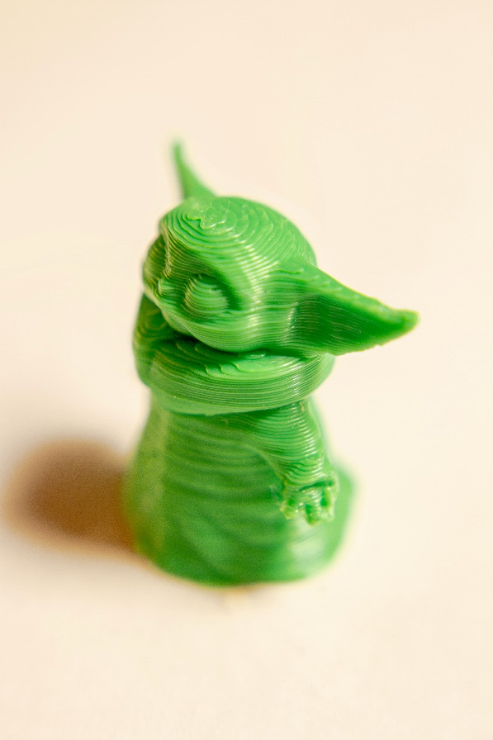

Core Listening Vocabulary

Activity A: Discussion

These are the key words for the first listening text of this unit. First, read the words. Then, discuss which words are new and figure out what they mean with a classmate or in small groups.

.

Activity B: Research

Research online to find the word type and definition for the words in the box below. Then, complete the table
Key Word Word Type Definition
Domestic Adjective

Commercial Related to buying and selling things
Layer Noun

Humanitarian Involved in or connected with improving people’s lives and reducing suffering
Adequate Adjective

Affordable Not expensive

Utensils Noun

Blueprint A photographic copy of an early plan for a building or machine
Research Verb

Industrial-sized A machine that is big enough to complete very large industrial tasks
Process Noun
Brainstorm To suggest a lot of ideas for a future activity very quickly before considering some of them more carefully

Activity C: Listen for the Answers

Read the following questions.
Then, listen to the answers A-F and match the answers to the questions.
When you have finished, share your answers with a classmate or in small groups.
Listen to Track 2

Questions
- How do 3D printers use layers to produce objects?

- Where do you get blueprints for 3D printers?

- What could we make with an industrial-sized 3D printer?

- Do you think the 3D printer could be used for humanitarian purposes? Why/why not?

- What commercial purposes could the 3D printer be used for?

- Do you think that 3D printer could be used to make domestic items more affordable?

Discussion
Discuss questions 3, 4, 5, and 6 with a classmate or in small groups. Try to think of as many answers as possible.

Activity D: Create

Write five questions and/or statements using the key words. When you have finished, share your questions or statements to a classmate or in small groups.

Listening Text: Academic Lecture on 3D Printing

Activity A: Notetaking

Listen to the lecture about 3D printing and how it can be used in humanitarian, commercial, and domestic environments. You should take notes as you listen to the lecture. You can write the notes in the box below.
Listen to Track 3
Writing notes can be a difficult skill. Here are some quick tips:
- Listen for the major points.
- Do not write every sentence you hear, write the key words.
- After you finish, read your notes and add extra details.

Activity B: Reflection

Share your notes with a classmate or in small groups.
You may ask and answer the following questions to help guide your discussion.

- What were some major points in the lecture?

- What were some minor points in the lecture?

- How can a 3D printer be used in humanitarian contexts?

- Do you think your local library should have a 3D printer? Why/why not?

- Do you think it would be beneficial to have a 3D printer in peoples’ homes?
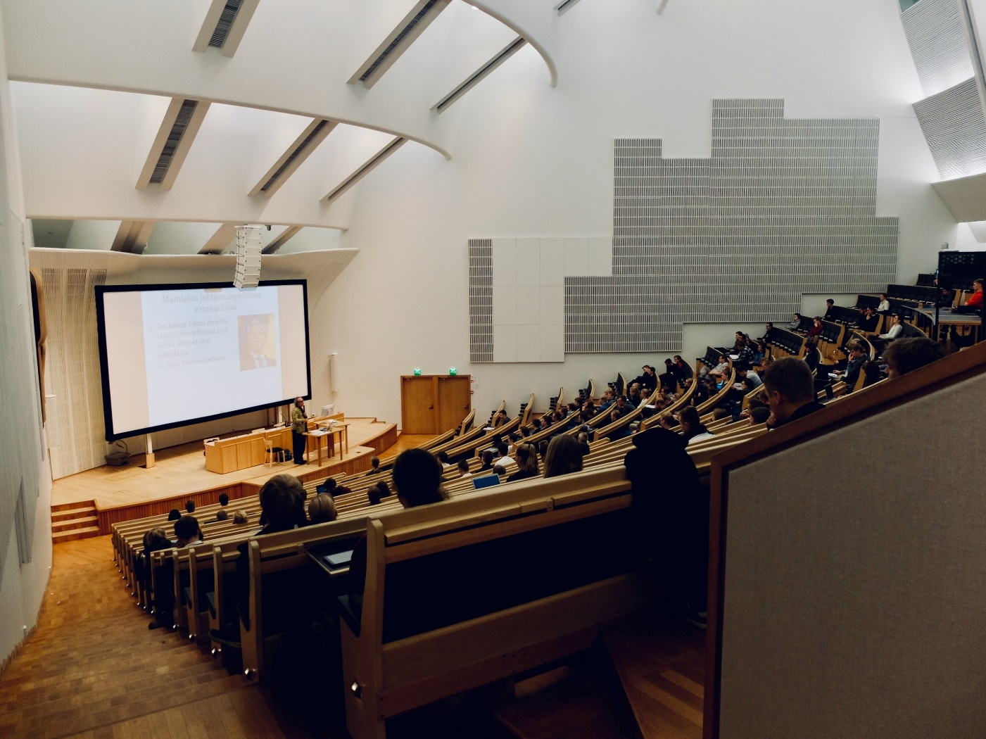

Critical Thinking: 3D Printing and my Community

Activity A: Discussion

Discuss the advantages and disadvantages of having a 3D printer in the following environments with a classmate or in small groups:
Your university
Your local library
Your home
Your local high school
Research Tip
When looking for a source, try to have a reliable website or research paper. You can usually use your university or college’s library website to find reliable sources. You can also try using Google Scholar.

Activity B: Research

Research online and find some benefits of having a 3D
printer in your house, community, school, or university.
Find evidence to support your ideas.
Discussion Tip

Make sure to cite your source. Cite your source according to your organization’s style guide. For example, APA, MLA, or Chicago-style.

Share your answers from Activity B with a classmate or in small groups. When a speaker has finished, ask them three follow up questions about the benefits.

Activity C: Discussion
Location Source Benefits

Homes

Local Libraries

Schools

Universities

Grammar Skill: Using Noun Clauses and Reporting Verbs
A noun clause is a group of words which we treat and use like a noun.
A noun clause includes a subject and a verb.

We often use certain words to introduce a noun clause, like who, what, where, when, which, that, if, how, and whether.

Example of a noun clause:
There is a business that figured out how 3D printers print household utensils.
We use noun clauses to give information in an engaging way.

Activity A: Identify the Noun Clauses

Listen to the following examples of sentences using noun clauses. As you listen, underline the noun clauses in your textbook. The first one is done for you.

Listen to Track 4

- Businesses are keen to find out how 3D printers print houses.
- Whether 3D printers are a viable option for producing medical supplies is becoming a frequently asked question in the medical field.
- The magazine showed which household items were possible to print in only 6 hours.
- I agree that an industrial-sized 3D printer has many benefits, including the ability to print houses.
- Most people agree that 3D printers should not be used for producing weapons.
- There is a lot of debate about which 3D printers are the most efficient.

Activity B: Structure of Noun Clauses

When using noun clauses, it is important to remember the structure.
Noun Clause Structure: Subject + verb

Listen to the following examples of correct and incorrect uses of noun clauses.
Then, write the number of the correct use of the noun clause in the space provided.

Listen to Track 5

Correct use of noun clause: ___

Correct use of noun clause: ___

Correct use of noun clause: ___

Noun clauses are frequently used with reporting verbs. Reporting verbs belong to a list of verbs that are used to report what other people have said.
Common Reporting Verbs
- Claim
- Say
- Explain
- Tell
- Argue
- Mention

Activity C: Noun Clauses and Reporting Verbs

Listen to the following examples of noun clauses and reporting verbs. Write the reporting verbs in the spaces provided.

Listen to Track 6

- _________
- _________
- _________
- _________
- _________

Activity D: Reporting Verbs and Noun Clauses

Listen to Track 6 again.
As you listen, write the reporting verb and the word after it. The first one is done for you.
Number Reporting Verb Following word
1 Explained how

2

3

4

5

Activity E: Using Noun Clauses to Report and Describe

Look at your notes from the Academic Lecture on 3D Printing. Report some of the information from the lecture on 3D printing using noun clauses. You can use some of the sentences below to guide your reporting.

Noun Clauses
- Whether… is not said in this article...
- The greatest benefit of 3D printing is (that)…
- Some people are reluctant to invest in 3D printing because they don’t understand…
- The speaker is unsure why…
- One major danger of 3D printers is that…
- The speaker points out that the 3D printer produces…
- I think the best thing is how the industrial sized 3D printer produces...
- Most people agree that 3D printers are useful for…

Research Tip
Remember to use noun clauses when sharing your notes.

Try to use some of the reporting verbs from this unit.

You should be able to talk about your article or video for at least 2 minutes.

Activity F: Research

Find a short article or video about 3D printing. Take some notes on the article or video. Then, share your notes with a classmate or in small groups.

Reporting Verbs and Noun Clauses
- In the academic lecture, the professor explained how…
- The speaker claimed that…
- The speaker also mentioned what…
- The speaker described how…
- In the video I watched, the professor claimed…

Pronunciation Skill: Syllable Count and Word Stress

Activity A: Word Type
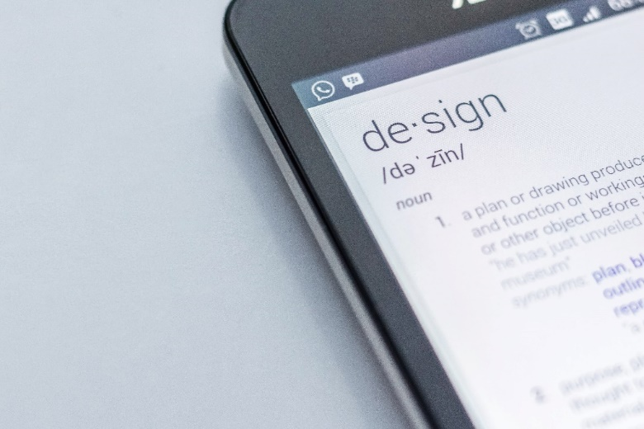
Syllable stress can change the meaning of a word.
Listen to the following sentences do the following:
- Identify the word type
- Write the meaning of the word

Listen to Track 7
Word Word Type Meaning
- Present

- Present

- Contrast

- Contrast

- Produce

- Produce

- Refuse

- Refuse

Activity B: Syllable Stress

Listen to the following sentences and identify where the correct stress on the word is.

Listen to Track 8
Word Noun Verb
- Present PRES-ent Pre-SENT
- Present PRES-ent Pre-SENT
- Contrast CON-trast Con-TRAST
- Contrast CON-trast Con-TRAST
- Produce PRO-duce pro-DUCE
- Produce PRO-duce pro-DUCE
- Refuse REF-use Re-FUSE
- Refuse REF-use Re-FUSE

Activity C: Tongue Twisters

Read the following sentences out loud and focus on correct pronunciation. Share your readings with a classmate or in small groups.

- The farm produces a lot of different produce, like cauliflower and carrots. I get all my produce at the farm and I love how my produce is produced.
- If we contrast the contrasts between the two different contrasting companies, we can understand that the contrasts are indeed contrasting.
- I don’t understand how some people refuse to dispose of their refuse correctly, it’s not that hard to separate refuse and I wish the companies would refuse to collect refuse if the refuse was not separated correctly.
- I presented my present at the birthday party but the present presented was not a good present and because I presented a bad present, I need to present a better present next year.

Functional Speaking Skill – Agree or Disagree and Reporting Verbs
When you are in university you will need to do group projects with classmates. Sometimes you will be in a group with someone you have never met. You might have different ideas for what you should do in the group project.

You may need to do the following when working with others:

- Disagree politely with people
- Cite or reference information

Activity A: What Can I Say?

Think of different phrases you can use to agree or disagree with another student. Write the phrases in the box below. Be prepared to share your answers with the class.
Phrases for Reporting an Idea
According to
Dr. Cloud said…
Your examples
Agree/Disagree with an idea
I agree
I disagree
Your Examples

Citations and References Tips:
If you want to give a strong argument, it is important to have citations and references. You should research online and find someone or something that supports your opinion.

Activity B: Which is Which?

Listen to the eight phrases below. As you listen, decide if they are an agree/disagree phrase or a reporting verb phrase by marking the correct column.
Listen to Track 9
Number Agree/Disagree Reporting Phrase
1.
2.
3.
4.
5.
6.
7.
8.

Activity C: Agree or Disagree?

Listen to the following phrases and as you listen identify if the phrases are agreeing or disagreeing phrases. Write the number of the phrase on the graph below. The first two are done for you.
Listen to Track 10
Critical Thinking
How formal or informal are the phrases? Discuss with your classmates.
2

1

Agree
Disagree

Activity D

Read the following statements to a classmate or in small groups.
Then your classmate(s) need(s) to respond by using one of the phrases they heard from page 25.
Language Tip
If you disagree with a person, use one of the disagreeing phrases.

After, you can use a reporting verb to give information on why you disagree.

Example
I’m not sure if I fully agree, if you look at the Kelowna library website, you can see…

- I think 3D printers should be made illegal.
- I think we should stay up late and study all night for the exam.
- There are no benefits to 3D printers.
- 3D printers are a good investment. I think I’ll invest all my money into 3D printers. What do you think?
- Did you know that they are designing a 3D printed car? I think they will be great.
- I am going to donate money to a charity that uses 3D printers to print houses. What do you think?

Core Speaking Vocabulary
What is a collocation?

Collocation: A noticeable arrangement or conjoining of linguistic elements (Merriam-Webster)

For example, is it make the bed, or do the bed? The answer is make, we always make the bed. This is an example of a collocation.

Words go together in patterns. Sometimes words go together a lot and they are known as collocations.
Some words have one collocation, we call these strong collocations, and some words have more than one collocation, we call these weak collocations.

Activity A: Useful Collocation

Each of the words below can be used in the sentences below. Read the words in the box. When you have finished, read the sentences below and inset the words from the box into the gaps. You may have more than one answer for each sentence. When you have finished, you can listen to the answers by clicking the link under number 6.
Conventional Commercial Industrial Three-dimensional
Claimed Adequate Affordable

- 3D printing is not your most __________ method of construction; However, it certainly is more affordable.

- An __________ sized 3D printer could help in the building of _______ and safe homes.

- In places where _________ housing is not available, a 3D printer could help solve homelessness.

- There are many ______ benefits to 3D printing, too. For example, it is possible to print clothing and household utensils.

- Dr. Smith ____________ that there might be some downsides to 3D printing, like the development of weapons and the time it takes to print larger items.

- For many, the concept of _____________ objects being printed is new.

Listen to Track 11

Activity B: Research

Using the key words from Activity A, research online and find more collocations for each of these words. Share your answers with a classmate or in small groups.

Speaking Text – 3D Printer or Something Else?

Read the following case studies and then role play one of them with a classmate.
Case 1: The library and the 3D printer

Your local library has received a grant from the government to buy some equipment for the library. Chris wants the library to purchase a 3D printer, but Emerson does not.

Chris has researched 3D printers and knows that they are expensive, but still believes the library should invest in a 3D printer.

First, Chris needs to explain how the 3D printer works, then she needs to explain how it could be beneficial for the library and the people who visit or live in the local community.

Chris and Emerson have a conversation about the 3D printer. Chris presents her reasons and opinions in a respectful way and Emerson needs to explain why she does not want the 3D printer. Each person needs to recognize the other idea in a respectful way.
By the end, Chris and Emerson need to agree on one thing: If they will or will not get a 3D printer.

Emerson’s List:

- We can’t make useful things with the 3D printer.
- The 3D printer is more confusing and will take too long to learn.
- The current set of computers and chairs are five years old.
- Children don’t need to learn about 3D printers.
Chris’ list:

- The 3D printer is easy to use.
- The 3D printer can be used to make anything, including medical or school supplies like mask clips, ventilator equipment, or even rulers.
- The 3D printer in a library is not uncommon and has been done before.
- It can help children learn the technology now, because it’s going to be VERY common in the future.

Case 2: 3D Printing and Charitable Purposes

Jamie works for Charity Worldwide. Jamie’s charity has been given a grant to help a community in a remote part of the world. Jamie thinks the charity should spend the grant on purchasing an industrial-sized 3D printer and teaching the locals how to use it. However, Jan thinks the grant should be spent on building wells and supplying food.

Jamie has a conversation with Jan to explain why the idea of a 3D printer is a good idea. Jamie explains how the industrial-sized 3D printer works, and then give three reasons why it is beneficial for this remote community. Jamie also tries to explain in a respectful way why the money should not be spent on wells and food. By the end, Jamie and Jan need to agree that an industrial-sized 3D printer is a good option.

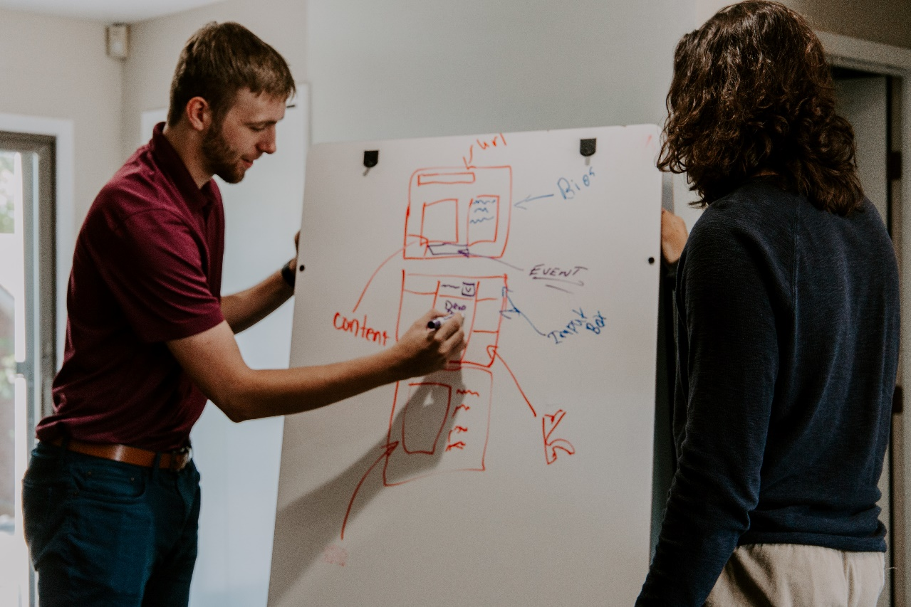

Presentation Skill: Describing a Process

When giving a presentation it is important to keep it engaging. It is important to be able to give a clear and well-organized presentation that includes specific vocabulary contextually.

The table circles below give useful words to use when describing a process. These words can be used to present ideas in an organized manner, or to describe a process of how something is created or done.

Activity A: Describing Different Processes

Read and discuss the following with a classmate or in small groups. Use some of the words from page 31.
Grammar Tip
We often use a mix of active and passive sentences when describing a process

Example:

Active: First, you download blueprints from the internet

Passive: First, blueprints are downloaded from the internet
- How to set up a movie account (like Netflix)
- How to make a cup of coffee or a nutritional shake
- How to bake a cake
- How a 3D printer can be used to make a house
Subject + Verb + Object
You download the blueprints.

- How a product is made

Subject + Verb (be) + Past Participle
The blueprints are downloaded.

Activity B: Active or Passive?

Another way to keep a presentation about a process engaging is to use both active and passive sentences. Listen to the following recordings of different processes being described. Try to identify if the speaker uses the active or passive tense when describing the process. Put an X under the correct title.
Listen to Track 12
Grammar Tip
We use the passive tense when we do not know who did the action or when it is not important who did the action.
Number Active Passive

1
2
3
4
5

Activity C: Identify the Process Words

Listen to Activity B again.
Write the process words which the speakers use. Then, use some of the phrases to describe
The processes in the pictures below.
Process Words Used
1
2
3
4
5
Presentation Tip
In this unit we have focused on noun clauses, key process words, sources, and reporting verbs. Try to use a combination of all to deliver a powerful presentation.

Making a cup of coffee or tea
Keeping a house tidy and clean

Activity D: Role Play

Read the following situations and respond to them with a classmate or in small groups. Try to use some words or phrases from this unit.

- 3D Printers and Housing
You believe that 3D printed houses could be the answer to homelessness and inadequate housing for lower income families. Discuss with your group why you believe this. Include three steps on how the 3D printer works and cite a relevant source.

- 3D Printers and Household Utensils
You believe that 3D printed household utensils offer a huge variety of commercial benefits. Discuss with your group why you believe this. Include three steps on how the 3D printer works and cite a relevant source.

- 3D Printers and Medical Devices
You believe that 3D printing can be used to create medical devices. Discuss with your group why you believe this. Include three steps on how the 3D printer works and cite a relevant source.

- 3D Printers are Overrated
You don’t believe the hype (excitement) surrounding 3D printers. Explain why you think they are not needed.

Unit Outcome

Read the following options A, B, and C. Then, prepare an answer for one of them. There are many ways to present your answer (interview, presentation, commercial, role play, advertisement, podcast, etc).
- 3D Printer and my Community Presentation
Presentation Tip
Research is important. Make sure to cite some reliable sources. Can you think of some places to get reliable sources?
Your community has been given a grant to have a 3D printer in the local library. You need to think of three uses for the 3D printer for your own community. Develop a short presentation for your local council on three different projects you can use the 3D printer in your own community. The presentation should discuss the three projects, explain how it works, and why it is beneficial.

Make sure to include:
- Noun clauses
- Vocabulary from this unit
- Process words
- A mix of active and passive sentences
- Agree and disagree phrases
- 3D Printer Advertisement
You work for a major 3D printing company and need to find a way to sell the 3D printer to the average household. Create an advertisement to sell the 3D printer. In your advertisement you should describe how the 3D printer works.

- Humanitarian Presentation

You work for a Non-Governmental Organization (NGO) and want to get a grant for a 3D printer. First, think of how the NGO could use the 3D printer for a humanitarian project. Then, develop a short presentation you can deliver to a funding agency explaining your project and why your team should be given the money to develop the project.
Photo Credits
Cover Page: Photo by ZMorph All-in-One 3D Printers on Unsplash
Page 7: Photo by Girl with red hat on Unsplash; Photo by Tom Claes on Unsplash; Photo by Trnava University on Unsplash
Page 11: Photo by Brooke Cagle on Unsplash
Page 13: Photo by Dom Fou on Unsplash
Page 14: Your home, by Scott Webb on Unsplash; Your local library, cottonbro from Pexels; Your local high school, Photo by NeONBRAND on Unsplash; Your university, Photo by Jane Last on Unsplash
Page 17: Photo by NeONBRAND on Unsplash
Page 20: Photo by Mimi Thian on Unsplash
Page 21: Photo by Edho Pratama on Unsplash
Page 30: Photo by Kaleidico on Unsplash
Page 33: Photo by Tyler Nix on Unsplash; Jason Leung on Unsplash

