Reaching Potential: Listening and Speaking Level IV
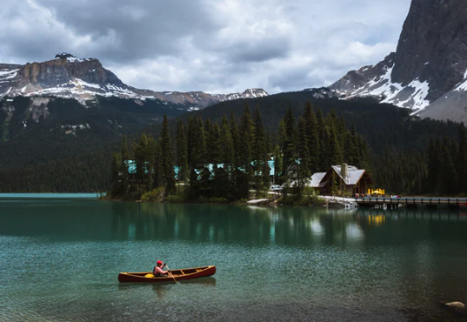
Geography
Ronan Scott
Reaching Potential: Listening and Speaking Level IV
Post Secondary Education Skills: Upper Intermediate English
(cc) Ronan Scott and the University of British Columbia’s Okanagan School of Education 2021
This work is licensed under a Creative Commons Attribution-Non-commercial-ShareAlike 4.0 International License.

Under the terms of the license, you are free to:
Share—copy and redistribute the material in any medium or format
Adapt—remix, transform, and build upon the material The licensor cannot revoke these freedoms as long as you follow the license terms.
Under the following terms:
Attribution — You must give appropriate credit, provide a link to the license, and indicate if changes were made. You may do so in any reasonable manner, but not in any way that suggests the licensor endorses you or your use.
NonCommercial — You may not use the material for commercial purposes.
ShareAlike — If you remix, transform, or build upon the material, you must distribute your contributions under the same license as the original.

Director, EAL Programs: Scott Roy Douglas
Program Coordinator, EAL Programs: Amber McLeod
Author and Layout: Ronan Scott
This project was funded, in part, by the UBC Okanagan Open education Resources Grant Program.
Published by:
English as an Additional Language Programs
Okanagan School of Education, University of British Columbia
1137 Alumni Avenue
Kelowna, British Columbia V1V 1V7
The photographs and artwork used in these materials may not be altered in any way without permission from the copyright holder, all information is listed on page 37.

TABLE OF CONTENTS
Geography in Canada 5
Activity A: Discussion 5
Listening Skill: Categorizing Ideas 6
Activity A: Notetaking 6
Activity B: Categorizing of Ideas 7
Core Listening Vocabulary 8
Activity A: Key Words 8
Activity B: Research 9
Activity C: Create 10
Activity D: Extension Activity 10
Create a Quiz 10
Listening Text: Canadian National Parks 11
Activity A: Points of Comparisons or Contrasts 11
Activity B: Listen and Take Notes 12
Activity C: Analyze your Notes 13
Critical Thinking Skills: Different Places to Visit 14
Activity A: Listen and Complete the Tables 14
Activity B: Read and Find 15
Activity C: Research and Create 16
Activity D: Short Radio Advertisement 17
Grammar Skill: Relative Clauses and Relative Pronouns 18
Activity A: Identify the Relative Pronoun 19
Activity B: Which Relative Pronoun do you Use? 19
Activity C: How to use Relative Clauses 20
Activity D: Changing Two Sentences to One 21
Activity E: Read the Transcript 22
Activity F: My Country 23
Pronunciation Skill: Pronunciation of ‘H’ 24
Activity A: Correct Pronunciation of WH Words 24
Activity B: Gap Fill 25
Activity C: WH- Questions and Answers 25
Functional Speaking Skill: Effective Paraphrasing 26
Activity A: Type of Paraphrase 27
Activity B: Effective and Ineffective Paraphrasing 28
Activity C: Paraphrasing and Citing 29
Activity D: Research and Paraphrase 29
Core Speaking Vocabulary 30
Activity A: Comparing and Contrasting 30
Activity B: Look and Match I 31
Activity C: Comparing and Contrasting in Canada 32
Activity D: Listen for Specific Information 33
Activity E: Look and Match II 34
Activity F: Canadian Geography Words 35
Activity G: Listen for Context 36
Activity A: Research 37
Speaking Text: National Parks and unique landscapes in Canada 37
Activity B: National Parks Discussion 38
Activity C: Listen and Match 39
Activity D: Research 40
Presentation Skill 42
Activity A: Identify the Citations 42
Activity B: Research Challenge 43
Unit Outcome: Canadian Geography 44

Geography in Canada

Activity A: Discussion

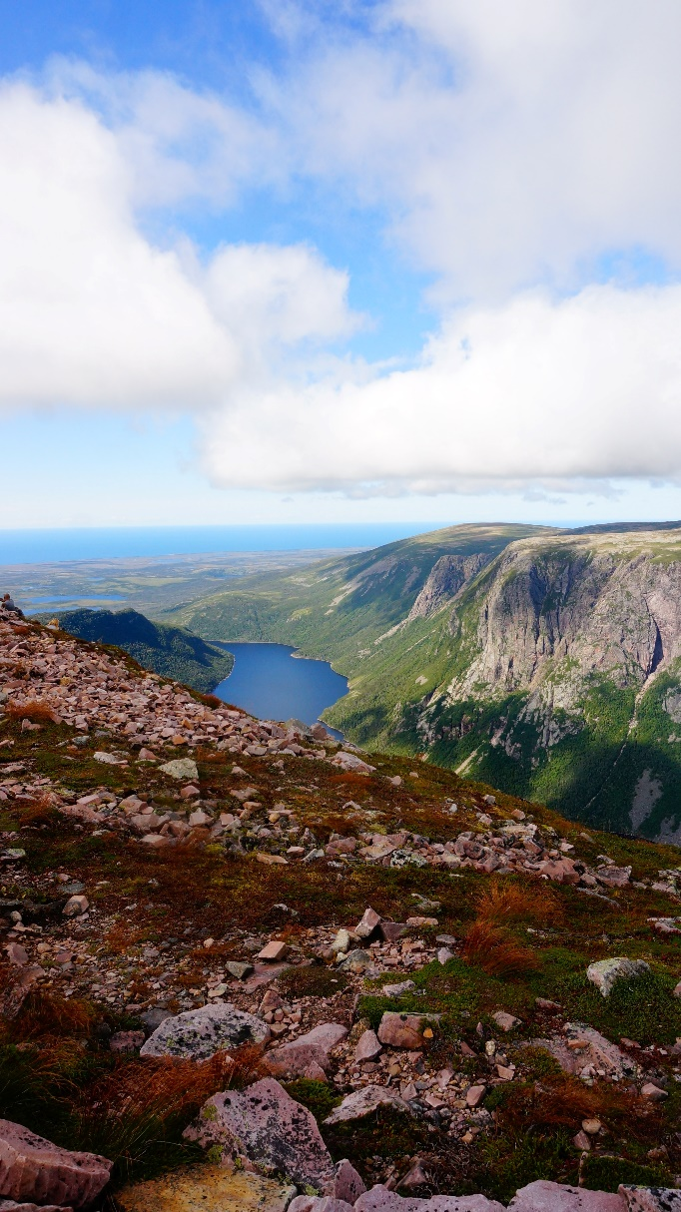

Listening Skill: Categorizing Ideas

Activity A: Notetaking
Categorizing ideas is an important skill in university.
You can categorize notes after a lecture to help you remember information.
Listen to the following conversation about two different national parks in Canada. As you listen, complete the table below with some information about each park.

Listen to Track 1
Gros Morne National Park
National Park Province Notes

Aulavik National Park

Gros Morne National Park

Activity B: Categorizing of Ideas

Reread your notes in Activity A.
Categorize the ideas into different sections and be prepared to present the information to a classmate or in small groups.
Study Tip
When categorizing notes, you can categorize information into different sections like:
- Size
- land features
- lakes, activities
- wildlife
- Location

Core Listening Vocabulary

Activity A: Key Words

These are the key words for the first listening text of this unit. First, read the words. Then, discuss which words are new and figure out what they mean with a classmate or in small groups.

Activity B: Research

Research online to find the definition for the words in the box below. Then, complete the table.
Key Word Word Type Word Definition
Construct Verb
Emerge Verb

Enormous Adjective
Maintain Verb

Feature Noun
Form Verb

Approximately Adjective
Abundant Adjective

Volcanic Adjective
Elevation Noun

Mineral Noun
Alpine Adjective

Activity C: Create

Write five questions and/or statements using the key words. When you have finished, share your questions or statements to a classmate or in small groups.

Activity D: Extension Activity
Choose one of the activities below.
Find a Picture for the Word
Choose five words from the list on page 9.
Find a picture online that will help you remember what the word is.
When you have finished, show the pictures to your classmates and have them guess what the word is.

Create a Quiz
Choose five words from the on page 7.
Make a quiz with missing words in it.
When you have finished, share your quiz with a classmate or in small groups and have them complete the sentences.

Example:
Canada has many ______ geographical areas. For example, the Okanagan Valley in BC is very different from the coast of BC.
Answer: diverse / unique

Listening Text: Canadian National Parks

Activity A: Points of Comparisons or Contrasts

When you attend university in Canada you will need to take notes in various environments. After you take notes, you can categorize your notes. Categorizing ideas and details and identifying comparisons and contrasts of different subjects are two important skills for university.

Identify some points of comparison or contrast for the following:

What is a Point of Contrast or Comparison?
A point of contrast or comparison is something you can use to compare or contrast a subject or subjects. Something similar or something different between a subject or subjects.

Music
Clothes
Food

Activity B: Listen and Take Notes

Canada is a country of natural beauty. Listen to the following conversation about four different national parks in Canada. As you listen, complete the table below with some information about each park.
Listen to Track 2
National Park Province Notes

Banff National Park

Mount Revelstoke National Park

Aulavik National Park

Gros Morne National Park

Activity C: Analyze your Notes
Revise your notes from Activity B and do the following:
- Categorize the information.
- Identify points of comparison and/or contrasts between the parks.
- Share your findings with a classmate or in small groups.

Study Tip
Ask yourself questions about the topic you want to identify points of comparison or contrast in. Look at the example below for ideas

Critical Thinking Skills: Different Places to Visit

Activity A: Listen and Complete the Tables

Listen to the radio about two different holiday resorts in BC, Canada. The advertisements talk about what you can do at the two locations. The advertisements also talk about the geography of each area. As you listen, complete the table below with information from the radio advertisements.
Listen to Track 3

Big White Telemark Nordic Club

Location

Activities

Price

What makes it unique

Activity B: Read and Find

Read the transcripts below, as you read do the following:
- Underline the activities you can do
- Circle the geographical features from the location
- Draw a box around the prices
This information is relevant for the radio advertisement. It gives the most important information in a quick manner. When you are creating a radio advertisement, you should make it short and engaging.
Big White Radio Advertisement
Are you looking for a getaway with the family to an alpine resort? Then look no further. Welcome to Big White Ski resort. Situated only 56 kms away from Kelowna, this is the perfect location for the entire family. From downhill skiing and snowboarding, cross country skiing, and even tubing, Big White is perfect for everyone. Don’t forget to check our alpine lakes!
Did you know that Big White is home to a 60-foot ice climbing wall? It’s the only one in the Okanagan!
What are you waiting for? Book today and get your beginner ticket for only $29!

Telemark Nordic Club Radio Advertisement
Come experience spring snowshoeing and cross-country skiing at Telemark Nordic Club. Only a short 30-minute drive from downtown Kelowna, it’s the perfect location for a day trip.
With over 17 trails, the largest of any Okanagan Snowshoe resort, you can snowshoe all day and never repeat the same trail.
When you have finished, make sure to stop by the Nordic Lodge and warm up by a fire with a nice tea or coffee or hot beverage.
Grab your day pass today for only $8 per person. Please note rentals may cost more.

Activity C: Research and Create

In Activity A you listened to a radio advertisement for two different holiday locations in BC, Canada. Now, complete the table below either using an interesting area in your country or one of the locations from page 17.
When you have finished, share the information with a classmate or in small groups.
Name: _________

Location

Activities

Price

What makes it unique

Activity D: Short Radio Advertisement

After you share your information with your group, decide which location you like the most.
Then, record a short radio advertisement for that location.
The radio advertisement should only be between 60-90 seconds long.
You should talk about:
- Where it is
- What you can do there
- What makes it unique
- How much it costs
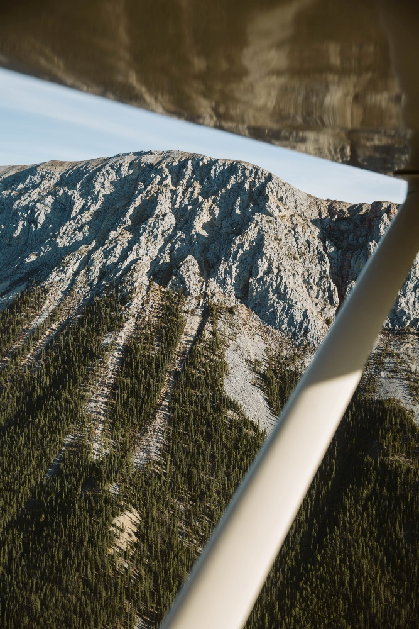

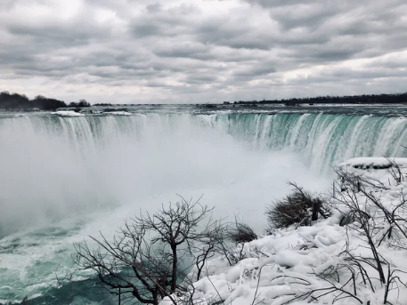
Niagara Falls
Yukon Territory
Emerald Lake

Grammar Skill: Relative Clauses and Relative Pronouns

We use relative clauses to give extra information about a noun.
Relative clauses can be effective for providing an engaging presentation.
We use a relative pronoun before the extra information.

Canada has many national parks which are maintained by the government.

Banff is a town in Alberta where you can go hiking, visit hot springs, and see wildlife.

Relative Pronoun
Relative Clause
Relative Clause
Relative Pronoun

Activity A: Identify the Relative Pronoun

Listen to the following sentences and identify the relative pronoun. Write the relative pronoun in the space below.
Language Tip
Relative pronouns are used to give extra information about a noun. Depending on the noun, we use different relative pronouns.
Who
Where
Which
When
That
Whose
Listen to Track 4
- ______________
- ______________
- ______________
- ______________
- ______________

Activity B: Which Relative Pronoun do you Use?

Listen to Activity A again. Identify if the relative pronoun is used for a person, place, thing, or a time. Put an X in the correct column. Share your answers with a classmate or in small groups.
Listening Person Place Thing Time
1
2
3
4
5

Activity C: How to use Relative Clauses

We use relative clauses to give extra information about a noun.
If you are talking about a place, you can mention the place and then use a relative clause to give some information about it.
Example:
Big White, which is in BC, is a ski resort.
The Yukon, where you can go dogsledding, is in Northern Canada and is tundra.
Big White is a beautiful ski resort where you can ski, snowboard, and go sledding.

Listen to the following expert from a travel agency talking about a town in Canada. Then discuss the questions below with a classmate or in small groups.
Listen to Track 5

Activity D: Changing Two Sentences to One

We use relative clauses to turn two sentences into one sentence.
Listen to the following two sentences.
Then, change the two sentences into one sentence using relative clauses.
Share your answers with a classmate or in small groups.
The first one is done for you.
Listen to Track 6

Number New Sentence

- Tourists who visit mount Revelstoke national park take pictures of wildflowers and sometimes see bears.

Activity E: Read the Transcript

Read the transcript below and:
- Underline the relative pronouns.
- Circle two sentences you could combine into one sentence.
Share your answers with a classmate or in small groups
Visit Revelstoke
Are you looking for a nice vacation this year with the family? Then look no further than Revelstoke, BC. Revelstoke, which is a small town of only 7,547 people, is located on the foot of Mount Revelstoke National Park.
Mount Revelstoke National park is a beautiful place where people visit winter and summer. In summer, many tourists who are interested in photography travel to the park to snap pictures of the beautiful wildflowers which bloom in July and August.
Consider going for a hike to some of the high alpine lakes like Jade and Eva lake. After your hike, you should check out the beautiful Halcyon Hot Springs which are located just a short 40-minute drive away from the town of Revelstoke. Immerse yourself in the hot springs which were formed by volcanic activity millions of years ago. The hot water is good for your skin. It is full of healthy and natural minerals from the earth’s core.
Revelstoke boasts natural beauty that was formed over centuries of geographical movement and has created lots of alpine lakes and jagged mountains. These jagged mountains are not difficult to climb.
Stay in the beautiful small town of Revelstoke. There are lots of restaurants and cafes you can visit in Revelstoke.
Overall, Revelstoke has fun for all the family. Book your trip today!

Listen to Track 5

Activity F: My Country

Look at the information you completed for Critical Thinking Skills, Activity D.
Share your information with a classmate or in small groups.
Useful Phrases
Let me tell about a beautiful place in my country which is located…
This area is known for ____ where you can…
The geography in this location is unique, which makes it perfect for…
In winter, when it is ___, you can…
Make sure to use relative clauses.

Pronunciation Skill: Pronunciation of ‘H’

Study the words in the box below. Then, listen to the pronunciation of the words in eight sentences. Identify if there a ‘H’ sound or no ‘H’ sound.

Activity A: Correct Pronunciation of WH Words

Listen to Track 7
Word ‘H’ sound No ‘H’ sound
- When
- Who
- Which
- Whose
- Where
- Whole
- White
- Wheel

Pronunciation Tip
When ‘Wh’ is followed by a long o or a oo sound, we use a ‘H’ sound
Most ‘Wh’ words do not use a ‘H’ sound

Without the H sound
When
Which
Where
White
Wheel
With the H sound
Long o or the oo sound
Who
Whose
Whole

Activity B: Gap Fill

Read the following sentences with gaps.
Complete the gaps with the correct WH words.
Then listen to check your answers.
Listen to Track 8

- ______ location has more hikes?
- Banff is a town ______ you can go hiking in the summer and skiing in the winter.
- ______ is the best time to visit Revelstoke?
- ______ do you think we should go next, Gros Morne or Banff?
- I can’t remember ______ suggested that we visit Revelstoke, but I am very glad they did.
- ______ idea was it to visit Aulavik national park? It’s too far away!
- Is there a place ______ we can hike and go to hot springs after?
- I think I’ll visit Revelstoke in the winter, ______ the snow arrives so I can ski all day.

Write five questions using the following words:
Who, Whose, Where, Which, When
Ask your classmates the questions and focus on correct pronunciation.

Activity C: WH- Questions and Answers

Functional Speaking Skill: Effective Paraphrasing

Paraphrasing is an important skill in English. When you are giving a presentation or sharing ideas you have two choices:

- Quote what you heard verbatim using citations
- Don’t repeat the information you read verbatim, paraphrase.

Paraphrasing is when we take what a person has said and repeat it in our own words but keep the message the same.
Verbatim | Adverb
Copied, quoted, or translated exactly the same words as were used originally

There are many ways to paraphrase in English, here are two:

- Change the grammar of a sentence
- Use new words with the same meaning
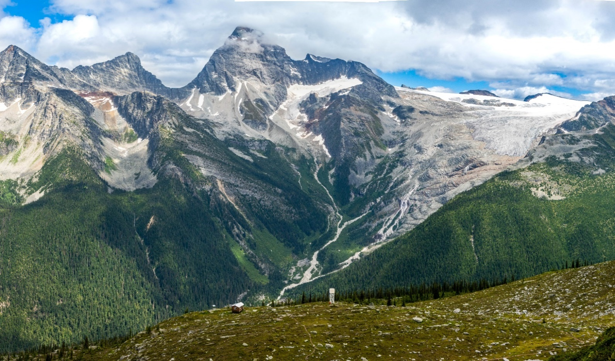
Glacier National Park

Activity A: Type of Paraphrase

First, listen to sentence A. Then, listen to sentence B. Sentence B is a paraphrased sentence. Identify what type of paraphing the speaker used. The first one is done for you. When you have finished, discuss the differences between A and B with a classmate or in small groups.

Listen to Track 9

Sentence Grammar Change New Word(s)

1 X

2

3

4

5

Activity B: Effective and Ineffective Paraphrasing

Effective paraphrasing is when you do not change the meaning of what was originally said.
Paraphrasing Tip:
Be careful not to misrepresent the facts. You can not change the meaning of a sentence when you paraphrase.
Listen to the following examples of effective and ineffective (A and B) paraphrasing. As you listen, put an X in the box which has the most effective paraphrasing for each.

When you have finished, discuss why you chose your answers.

Listen to Track 10

Original Statement A B
1
2
3
4
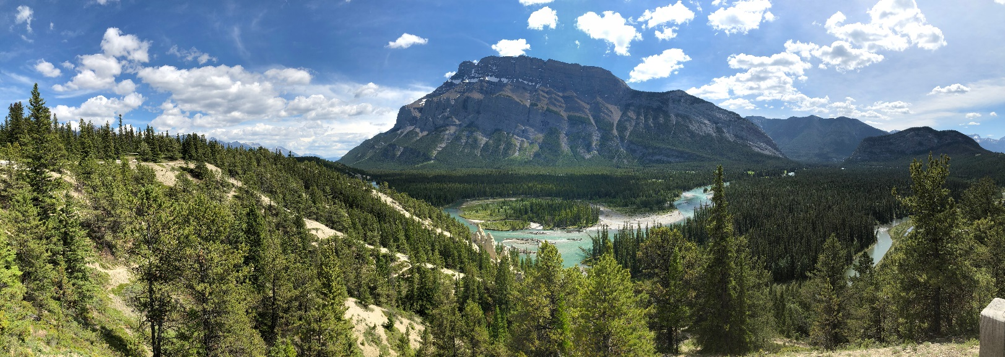
Banff National Park

Activity C: Paraphrasing and Citing

Read the following sentences. Then paraphrase the sentences. Read your paraphrased sentence to a classmate or in small groups. Then, your classmate or group should give you feedback.

- According to the brochure, Mount Revelstoke National Park is located in BC. It is not the biggest national park, but it is beautiful.
- This article says many people visit Banff National park every year to experience the world-famous hot springs.
- Big White ski resort is a lot smaller than Revelstoke National Park. However, it is perfect for family vacations.
- Professor Scott says that unless we do something about climate change, the national parks will change drastically in the next two decades.
- Revelstoke National Park is full of beautiful geographical features like jagged mountains and alpine lakes.
- The Canadian Statistics office reports that Revelstoke National Park has over 600,000 visitors annually.
Language Tip
When you paraphrase, you may need to give citations.
Make sure to give the proper citations for information you paraphrase.

Activity D: Research and Paraphrase

Research an area in your country that is geographically unique. Find some points of information about the area. Then, share your information with a classmate or in small groups. When you share the information, make sure to paraphrase effectively.

Core Speaking Vocabulary

Activity A: Comparing and Contrasting

When you are giving a presentation in university, you may need to compare and contrast the similarities or differences between two different subjects. Study the list of words below.
What is the difference between compare and contrast?
Compare | Identify the similarities between two things
Contrast | Identify the differences between two things

Comparing and Contrasting words:

Activity B: Look and Match I
Look at the pictures below and:
- Describe the pictures with a classmate or in small groups
- Connect the pictures with words from page 32

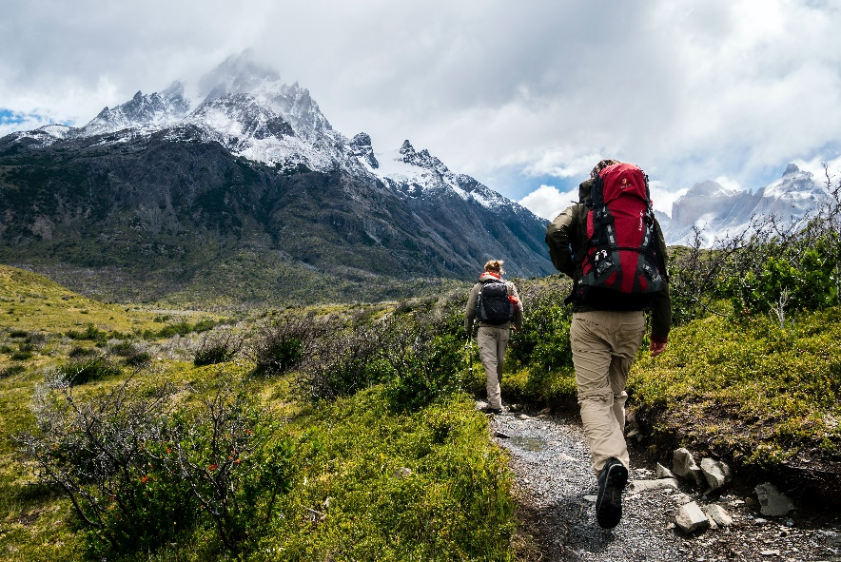
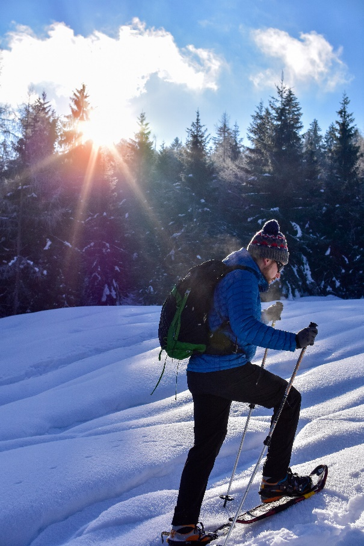
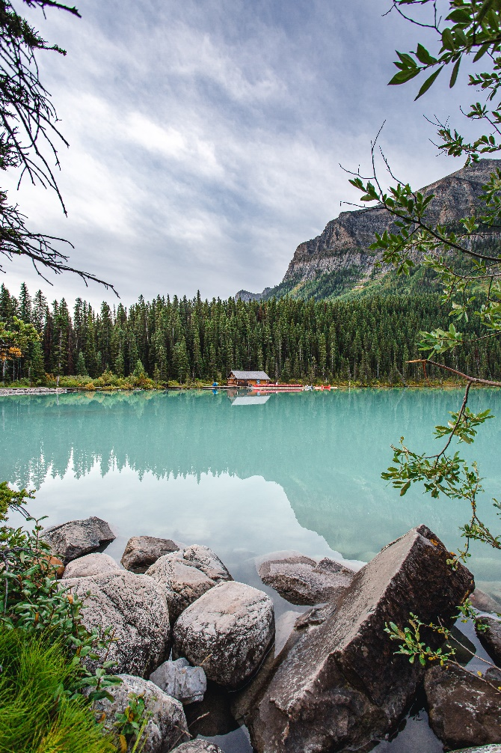
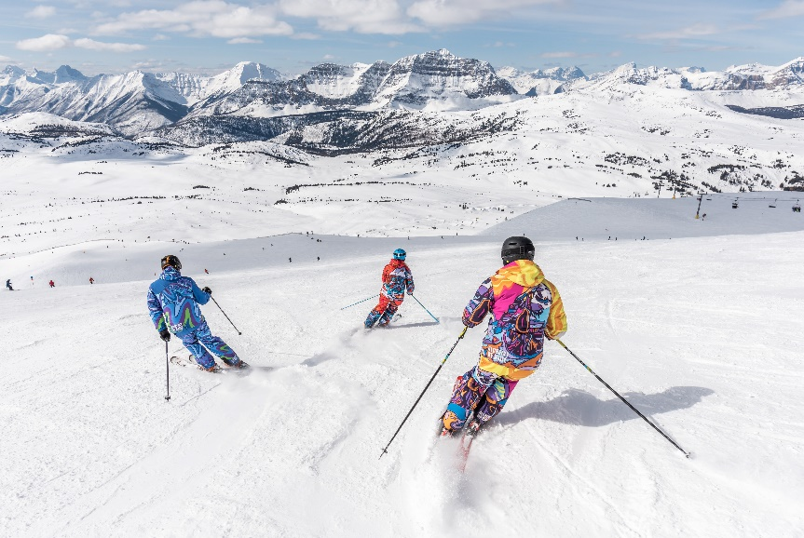

Activity C: Comparing and Contrasting in Canada

Listen to the following conversation about two different locations in BC, Canada.
As you listen, put an X in the box for the location which has the information listed.

Listen to Track 11
Information Big White Both Mount Revelstoke
Snowshoeing
Hiking
Skiing
National Park
Alpine Lakes
Wildflowers

Activity D: Listen for Specific Information

Listen to Track 11 again. As you listen, write the context in which the word was used. The first one is done for you.
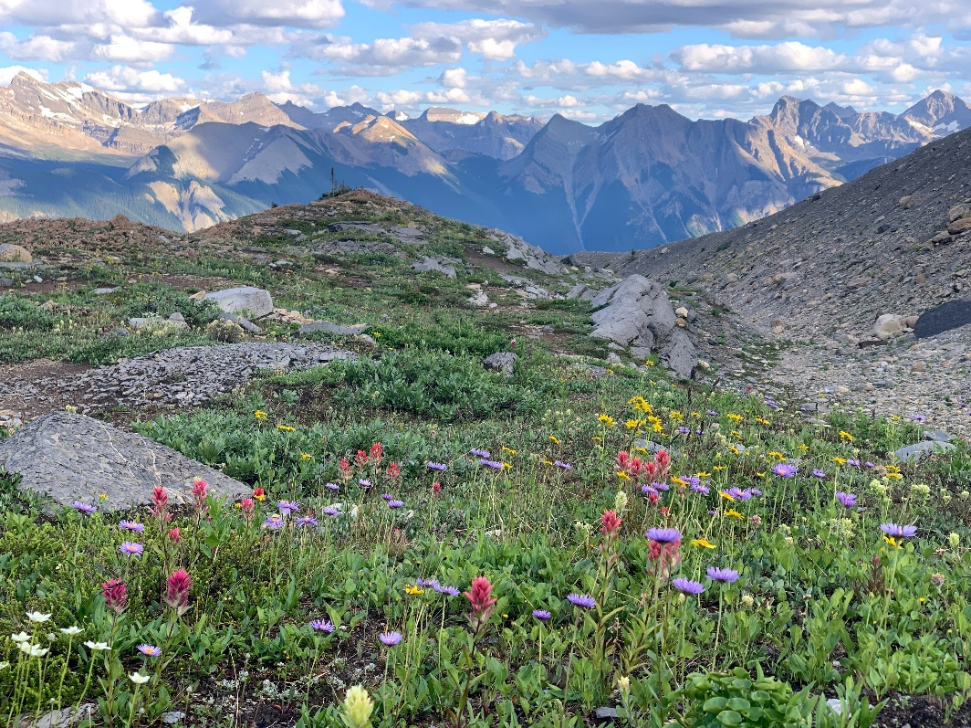
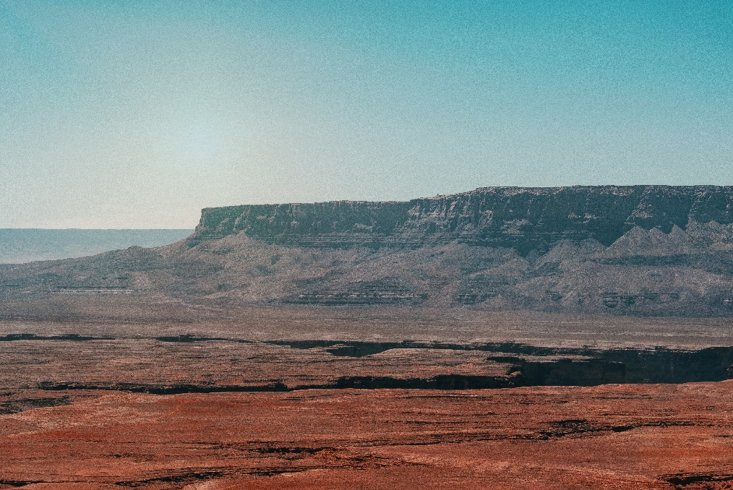
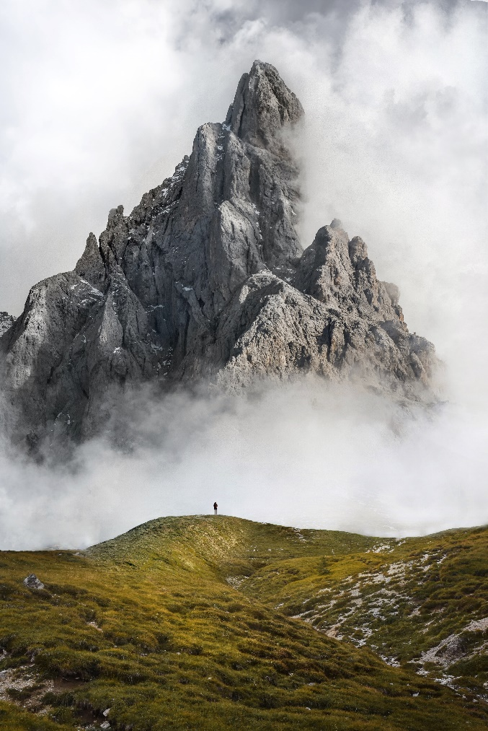
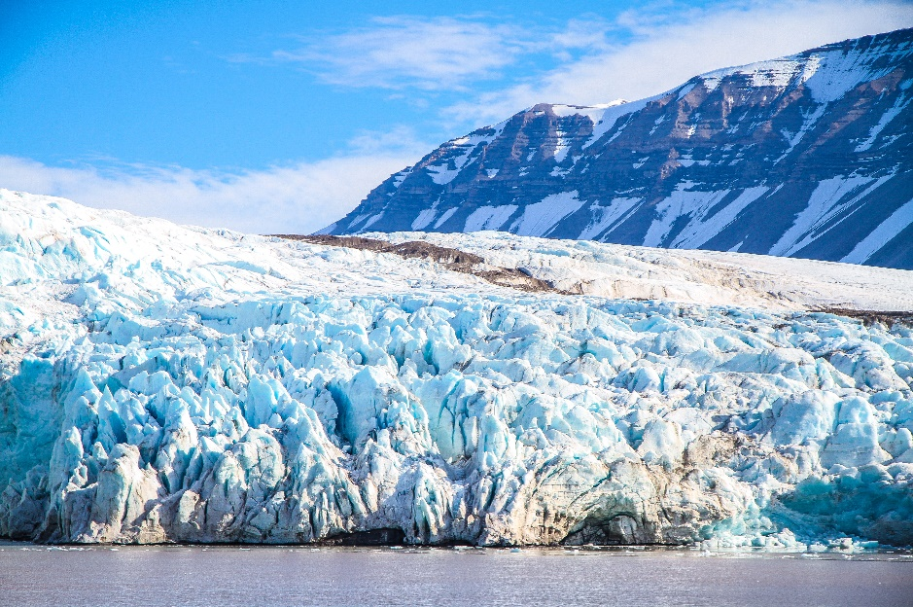
Comparing and Contrasting Words Context

In comparison to The speakers use this to compare Big White and Mount Revelstoke. They talk about the differences between the height of the mountains.

In contrast

On the one hand / on the other hand

In common

However,

Activity E: Look and Match II
Look at the pictures below and:
- Describe the pictures with a classmate or in small groups
- Connect the pictures with words from page 35

Activity F: Canadian Geography Words

Study the words in the box below. Then complete the table with the correct word type and definition. When you have finished, share your answers with a classmate or in small groups.
Key Word Word Type Definition
- Geographical features

- Plateau

- Limestone

- Glacier

- Peak

- Wildflowers

- Subalpine

Activity G: Listen for Context

Listen to Track 11 again. As you listen, try to identify some words from the box below. Then, write some information about the word you heard.

Key Word Context
- Geographical features

- National park

- Glacier

- Peak

- Wildflowers

- Subalpine
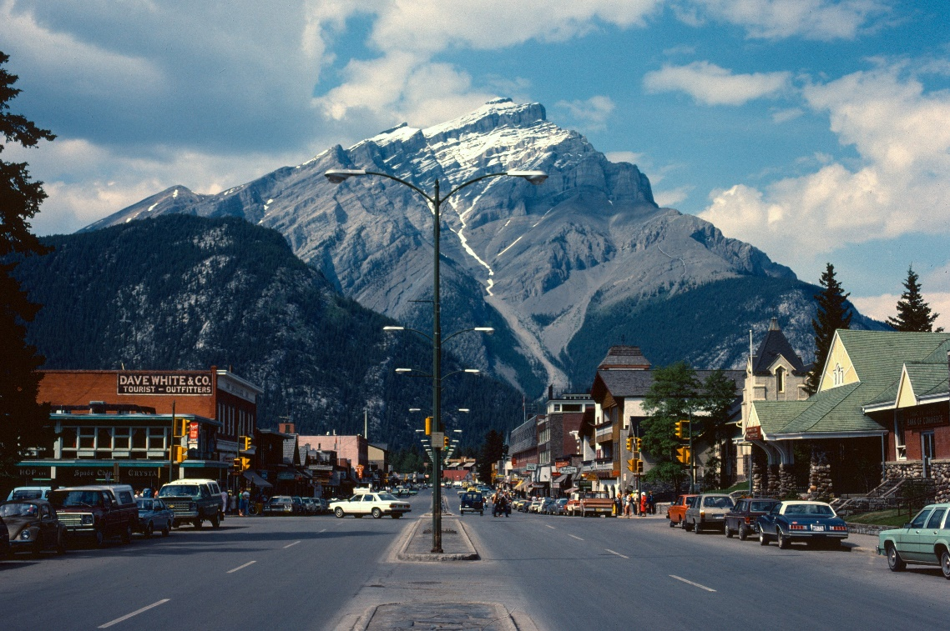
The city of Banff

Activity A: Research

Speaking Text: National Parks and unique landscapes in Canada
Did you know Canada has 48 national parks?
Language tip:
Use relative clauses when sharing your information

Two popular national parks are:
- Banff National Park
- Mount Revelstoke National Park

Choose one of these national parks and research it online.
Try to find the following:

Activity B: National Parks Discussion

Read the information below about Banff and Mount Revelstoke.
Find points of comparison or contrast.
Then, paraphrase the information.
Share your answers with a classmate or in small groups
Banff National Park
Location: Alberta
Date established: 1885
Size: 1,641,027 acres
Annual visitors: 4 million

Geographical Features
- Rugged and mountains.
- High alpine peaks.
- Subalpine landscape.
- Montane landscape.
- Mountains in the region are composed of limestone, shale, and other sedimentary rocks.

Recreational Activities
Boating, kayaking, hiking, camping, skiing, snowboarding.
Mount Revelstoke National Park
Location: British Columbia
Date established: 1914
Size: 260 square kilometres
Annual visitors: 600,000

Geographical Features
- Formed 250 million years ago by the collision.
- of the North American and Pacific Plates.
- Range was covered by the Cordilleran ice sheet until as recent as 6,000 years ago.
- Ancient igneous and metamorphic rocks.
- Jagged mountain peaks and small lakes.
- Subalpine meadows.
Recreational activities
Hiking, photography, backwoods camping, snowshoeing, cross country skiing.

Activity C: Listen and Match

Listen to the following recordings and take notes.
The recordings talk about Banff and Mount Revelstoke National Park.
When you have finished, compare your notes to the information on page 38 and identify if the recording is talking about Banff or Mount Revelstoke.
Write your answers in the box below.
Listen to Track 12
Listening Location
1
2
3
4

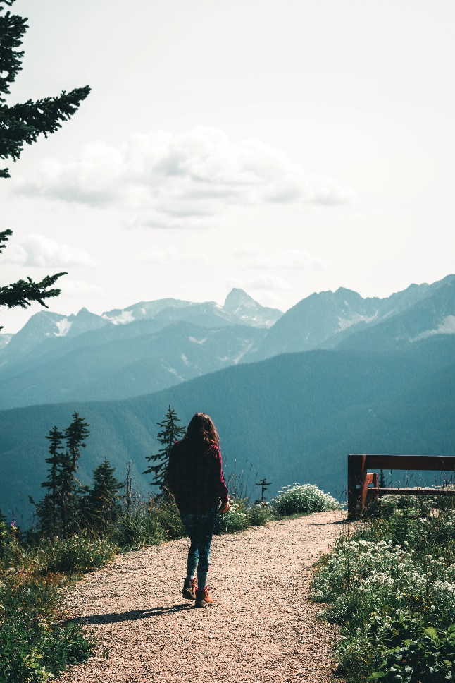
Mount Revelstoke National Park

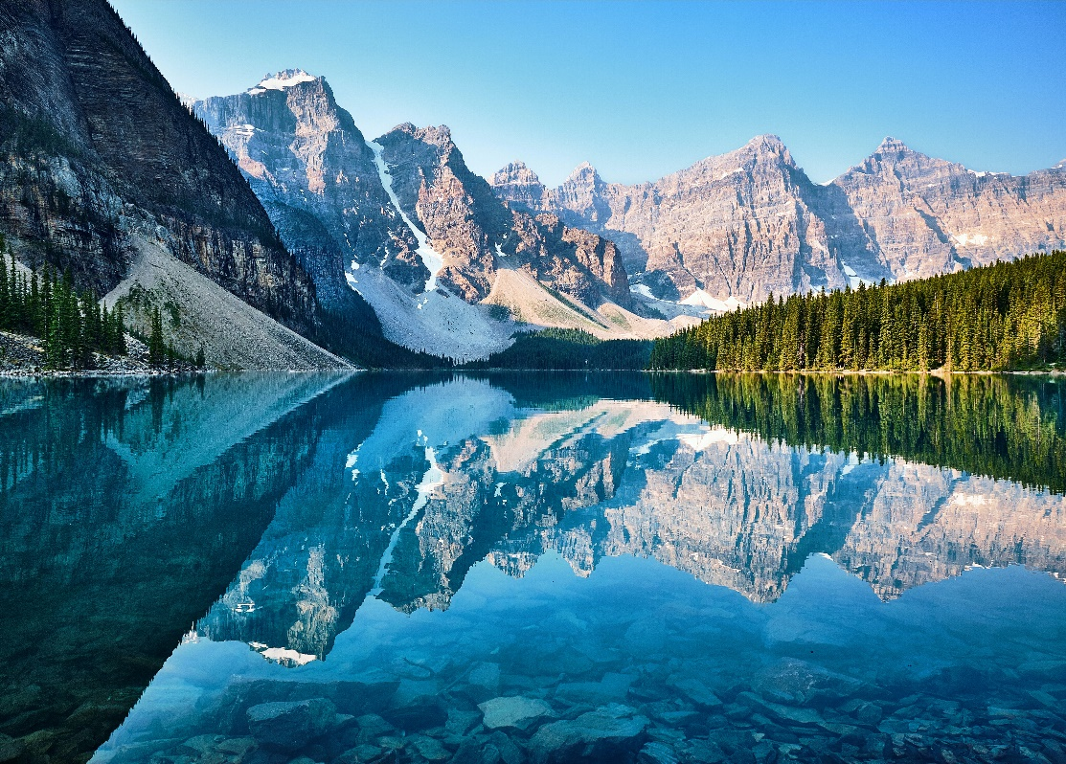

Moraine Lake, Banff National Park

Activity D: Research

Read the information in the box below.
Language Tip
When you compare and contrast, you should use a combination of:

- Paraphrasing
- Relative Clauses
- Vocabulary from this unit

You can also use some of the sentence prompts on the next page to guide your conversation.

- Where it is
- What is unique about it
- Some geographical features of the area
- What activities you can do in the area

You are going to visit BC but only have enough time to visit one location.
There are several places you want to visit.

- The Okanagan Valley
- Bear Creek Provincial Park
- Skaha Lake
- Osoyoos

Research online and compare and contrast two different locations with a partner or in small groups.

Find out:

Then, choose which place you will visit.

Language tip:
Use the phrases from the next page when talking about your research

Use these prompts to describe different places:

- I think we should go to… because…

- The high mountain, which is called…

- Banff, which is…, has…

- There is a big lake where you can…

- Have you heard of Skaha Lake? It’s a beautiful lake that…

- John said it’s a place that/where….

- You can take pictures of mountains that…

- The highest mountain is ______ which is…

- I think we should go to ______ where you can…

- I like ____, which is…

- The Okanagan Valley, where you can…., is…

- The brochure says that Mount Revelstoke, which is in BC, is a beautiful national park.

- There are lots of jagged mountains that…

- It’s a big lake, which has…

Presentation Skill

An important skill when giving a presentation in university is using information from online and or/printed reference sources. You need to correctly cite the person or organization that you are including in your presentation.
Online and/or printed references sources
- A source is somewhere you get information
- A brochure is an example of a printed source
- A website is an example of an online source. Some websites are more credible than others. For example, social media is not an academic source; However, social media can be used to get information from people who have visited places (reviews of a location). These are useful for giving information in an informal situation.
- In a university presentation, you should only use reliable and credible sources. In a regular conversation or non-academic situation, you can use any source.

Activity A: Identify the Citations
Listen to the following examples of using cited information.
As you listen, identify the phrases and sources used.
Write your answers in the box below.
When you have finished, share your answers with a classmate or in small groups.

Listen to Track 1

Listen to Track 13
Listening Citation Phrase Source
1
2
3

Activity B: Research Challenge

Study the phrases below for referencing online and/or printed sources
Phrases for referencing:
According to…
It says on the website that…
This is a beautiful place which the website says…
The brochure states…
The website also mentioned that…
The author of the travel book explained that…
The most recent government publication indicates there is…

Research Challenge
In the Critical Thinking section of this unit you researched areas in your own country that people like to visit. Research this area again but look for what people or organizations have said about this area. Try to find some facts about this area from an official website or related websites.
Share the information with a classmate or in small groups. Use some of the phrases from the box above when you are speaking.

Unit Outcome: Canadian Geography
In this unit we have studied:
- Geography
- Unique Geographical Areas and Features
- Relative clauses
- Citation Skills
- Pronunciation Skills
- Paraphrasing Skills
Try to use some of these in your unit outcome activity
Read the activities below, then choose one activity to complete with a classmate or in small groups.

Activity A – Conversation about an upcoming holiday
You are going on holidays. You each need to prepare a short presentation of where you want to go on holidays.
You should include the following information:
- What you can do there
- The geography of the place and why it is relevant
- Some information from the a credible online and/or printed source

Record a conversation between you and your classmates discussing the different places. You should compare and contrast the locations. By the end, you should all agree on what place you will visit.

Did I include:
- Two or more citations
- Two or more relative clauses
- Paraphrasing
- Vocabulary from this unit
Activity B - Academic Presentation on an area of unique Geography

You need to prepare short academic presentation about a unique area either in your country or in Canada. The presentation should describe the area and the geography.
Photo Credits
Cover Page: Photo by Luc Tribolet on Unsplash
Page 6: Photo by Krista Kankula on Unsplash;
Page 16: Photo by Eric Nopanen on Unsplash
Page 17: Emerald lake, Photo by Luc Tribolet on Unsplash; Niagara Falls, Photo by Micah Giszack on Unsplash; Yukon Territory, Photo by Kristina Delp on Unsplash
Page 26: Photo by Jonathan Woods on Unsplash
Page 28: Photo by Steve Payne on Unsplash
Page 31: Snowshoeing, Photo by Sandra Grünewald on Unsplash; Skiing, Photo by Banff Sunshine Village on Unsplash; Hiking, Photo by Toomas Tartes on Unsplash; Alpine Lake, Photo by Pietro De Grandi on Unsplash
Page 34: Plateau, Photo by Gabriel Tovar on Unsplash; Wildflowers, Photo by Kristy Dixon on Unsplash; Peak, Photo by Massimiliano Morosinotto on Unsplash; Glacier, Photo by Vince Gx on Unsplash
Page 36: Photo by Krista Joy Montgomery on Unsplash
Page 39 Moraine Lake, Photo by John Lee on Unsplash; Mount Revelstoke National Park, Photo by Ali Kazal on Unsplash

