Geographical Processes
Reaching Potential: Listening and Speaking Videos
Anderson, McLeod, Moore, Scott
Reaching Potential: Listening and Speaking Videos Level IV
Post Secondary Education Skills: Upper Intermediate English
(cc) Anderson, McLeod, Moore, & Scott, & The University of British Columbia’s Okanagan School of Education 2021
This work is licensed under a Creative Commons Attribution-Non-commercial-ShareAlike 4.0 International License.
Under the terms of the license, you are free to:
Share—copy and redistribute the material in any medium or format
Adapt—remix, transform, and build upon the material The licensor cannot revoke these freedoms as long as you follow the license terms.
Under the following terms:
Attribution — You must give appropriate credit, provide a link to the license, and indicate if changes were made. You may do so in any reasonable manner, but not in any way that suggests the licensor endorses you or your use.
NonCommercial — You may not use the material for commercial purposes.
ShareAlike — If you remix, transform, or build upon the material, you must distribute your contributions under the same license as the original.
Director, EAL Programs: Scott Roy Douglas
Program Coordinator, EAP Programs: Amber McLeod
Design: Ronan Scott and Amber McLeod
Writers: Amber McLeod, Don Anderson, Nicole Moore, & Ronan Scott
This project was funded, in part, by the UBC Okanagan Open education Resources Grant Program.
Published by:
English as an Additional Language Programs
Okanagan School of Education, University of British Columbia
1137 Alumni Avenue
Kelowna, British Columbia V1V 1V7
The photographs and artwork used in these materials may not be altered in any way without permission from the copyright holder, all information is listed on page 13.
Contents
Activity A: Discussion 4
Activity B: Share and Compare 5
Activity C: Vocabulary 6
Activity D: Discussion 7
Activity E: Kalamalka Lake 8
Activity F: Matching 9
Activity G: Comprehension 10
Activity H: Reflection 12
Photo Credits 13

Activity A: Discussion

Discuss the following questions with a classmate or in small groups.

Activity B: Share and Compare

Show photos of your home country or region to a classmate or your group. Compare the photos to Canada and/or to your classmates photos. Be prepared to share your findings with your class.
Language Tip
You can use some of these words to compare:
- However,
- Whereas,
- Compared to
- On the one/other hand
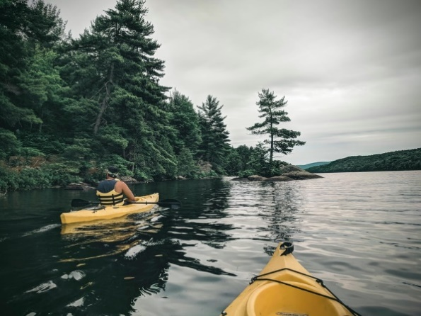

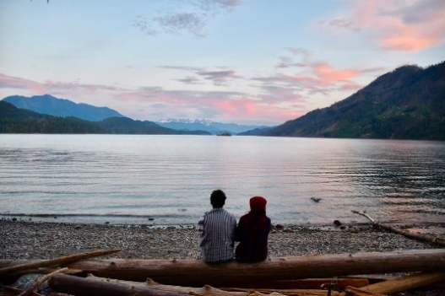

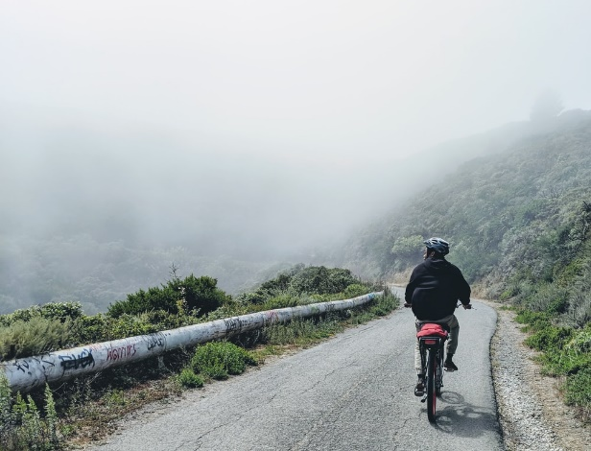

Activity C: Vocabulary

Before you watch the educational video, review the key words below.
Write a definition and example sentence for at least six of the words. Share your answers with a classmate or in small groups.
Study Tip
Got a new word? Look it up online and write a definition and example sentence to help you remember it
Key Word Definition Example
1. Basin
2. Crystallization
3. Erosion
4. Fault
5. Fjord lake
6. Glacier
7. Marling
8. Mesozoic era
9. Photosynthesizing
10. Richter Scale
11. Sediment
12. Seismic Movement
13. Silt
14. Syilx
15. Unceded territory
16. Weathering

Activity D: Discussion

The educational video for this unit is based on Kalamalka Lake. Kalamalka Lake is situated in British Columbia. Before watching the video, look up some answers for the questions below. When you have finished, share your answers with a classmate or in small groups.

Research Tips
- When you are looking up information on a new topic, use key words.
- Find more than one source of information

Activity E: Kalamalka Lake
Read the following questions before you watch the video. Then watch and the video take notes. When you have finished, answer the questions.

- What are three characteristics about Kalamalka lake that you heard and remembered?

- What are two new vocabulary words that you learned about in this video?

- What is an example mentioned about erosion?

- What are some activities you can do at Kalamalka lake?

- What surprised you about the information in the video?

- Is there anywhere in your country that is similar to Kalamalka lake?

Notes
Watch the Kalamalka Lake video

Activity F: Matching

Match the following words to the pictures below. Then, with a partner, try to give one sentence explaining each picture

.

Unceded Territory

Marling

Weathering and Erosion

Basins

Fault Lines/ Seismic Activity

Activity G: Comprehension
Read and answer the following questions on pages 9 and 10. Share your answers with a classmate or in small groups.

1. The colour of the lake comes from __________ deposits.
a) granite
b) limestone
c) basalt
2. Western rock along the Okanagan Rail Trail was formed during the ________ era.
a) Cenozoic
b) Paleozoic
c) Mesozoic
3. The process of marling is best created in what season?
a) Fall
b) Summer
c) Winter
4. Which scale measures the strength of earthquakes from seismic movements?
a) Richter Scale
b) Pentatonic Scale
c) Richard Scale
5. What type of weathering is found on the Rail Trail?
a) Mechanical
b) Chemical
c) Biological
6. How long ago did volcanic magma erupt and flow down the Okanagan Valley?
a) 20 - 25 million years ago
b) 10-15 million years ago
c) 50-100 million years ago

7. What extreme example of weathering and erosion is found in Arizona?

8. Various coastal mountain ranges of North America were formed in stages by the movement of tectonic plates. What is this process called?

9. How was the southern subbasin of Kalamalka Lake formed?

10. What was most interesting to learn about Kalamalka Lake for you?

Activity H: Reflection

Choose one of the following reflection activities to complete with a classmate or in small groups.
Reflection 1
- How is this lake similar or different from a lake surrounding or close to your hometown and what are some things you can do help preserve lakes near you?

Think about the geographical phenomena that were discussed in the video and link your personal ideas for conservation with the processes discussed in the video.

Reflection 2
- At the beginning of the video you heard a land acknowledgment to the Syilx people of the Okanagan. Create your own land acknowledgment for the ancestors of the land that you now occupy.

Photo Credits

Cover Page: James Wheeler from Pexels
Page 5 from top down: Ali Kazal on Unsplash; Megan Byers on Unsplash; Noah Rosenfield on Unsplash

